A Color-Magnitude Diagram for Type I AGN
Educator Team: Nicole Granucci, Theresa Paulsen, Thomas Rutherford
Mentor Teacher: John Blackwell
Science Mentor: Varoujan Gorjian

Abstract

Data from the Sloan Digital Sky Survey (SDSS) and the Galaxy Evolution Explorer (GALEX) satellite will be used to extend the work of the 2010 and 2012 NITARP teams in demonstrating a correlation between the luminosity and color (temperature) of the accretion disk within Type I Active Galactic Nuclei (AGN). The 2012 NITARP team was successful in finding a trend in the UV luminosity and color of the AGN in Type I quasars, however the sample size was not sufficient in demonstrating a substantial correlation. More data is needed to complete the plot; therefore, data from less luminous AGN must be used. Our project will attempt to examine whether the trend remains the same for Type I Seyfert galaxies with redshifts 0.1 < z < 0.5.

Background

Active Galactic Nuclei (AGN) are the centers of some of the most violent and active galaxies in the universe. The intensity is so bright that when viewing from earth, the galaxies can look like point sources, or stars. It is speculated that this is caused by super-massive black holes at the center of these galaxies actively drawing matter into an accretion disk. As matter speeds up under the gravitational force of the black hole, thermal processes in the accretion disk cause the disk to radiate light across the entire electromagnetic spectrum, peaking in ultraviolet.

The two largest subcategories of AGN are quasars and Seyfert galaxies. The primary difference between them is in the amount of radiation produced in their cores. Quasars are extremely bright, having luminosities that exceed the all of the stars in the host galaxies by about 100 times (10¹³ L⊙). The light from a quasar’s core is so bright that is overwhelms the light of the remainder of the galaxy. Seyfert galaxies have the less luminous AGN. The luminosity of the cores of these galaxies is approximately equal to that of all the stars in the host galaxy (10¹¹L⊙).

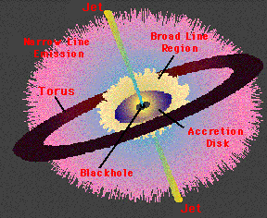
AGNs contain a concentration of dust in a ring around the accretion called a torus. (Figure 1) According to the Unified Model of galaxies, when a galaxy is tilted toward earth such that we can see into the center of the ring, the light from the accretion disk is nearly unobscured by dust and velocity broadened hydrogen emission lines can be seen in the spectra due to the intense speed of gas clouds encircling the black hole. Galaxies in this orientation are classified as Type I galaxies. Type II galaxies are oriented in such a way that we cannot see into the ring and therefore the light from the accretion disk is obscured and only narrow emission lines from the outer gases are visible. For this reason, only Type 1 galaxies will be targets of this investigation.
Figure 1
A drawing of the typical AGN

Scientific Goals

Type I Seyfert galaxies will be examined using data provided by the NASA Extragalactic Database (NED). Specifically, galaxies that were imaged by both SDSS and GALEX will be studied. The goal is to continue the work of the 2012 team to produce a color magnitude diagram (CMD) showing the theorized correlation between UV luminosity and color of Type I AGN. This project will extend the earlier results using quasars (Figure 2) to include less luminous AGN.
Figure 2: 2012 Team Results
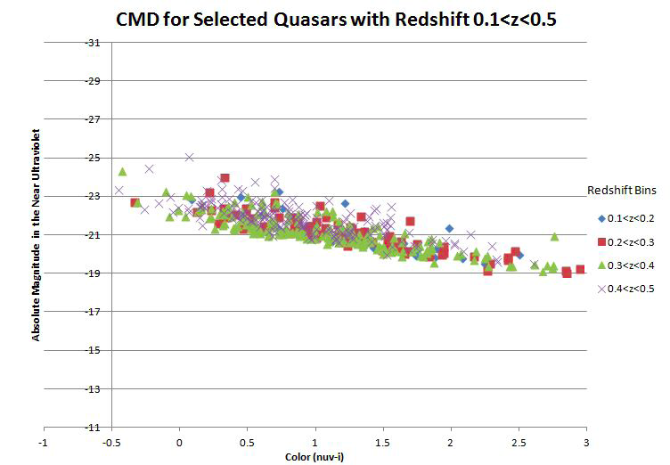
As in the case of the 2012 NITARP team, color index will be determined as the difference between the fluxes in the near ultraviolet (from Galaxy Evolution Explorer, GALEX) to the z band (from Sloan Digital Sky Survey, SDSS). The formula, Color Index = Near UV – z band, will be used.

We intend to:
- Focus on nearby Type I Seyfert galaxies to avoid obscuration of the accretion disk. Sources will be selected at similar redshift values (0.1< z <0.5) to be consistent with the 2012-team data and to avoid the need to correct for redshift variation.
- Use photometry data obtained within approximately a 5-year period to minimize error due to variability.
- Use data from GALEX and SDSS to increase the number of wavelengths available. Due to the redshift of these sources, GALEX data alone cannot be used since redshifted Lyα lines are a strong contaminant at the wavelength measured by the far UV GLAEX filter. Only the GALEX near UV filter can be used. SDSS z-band measurements will be used for a second UV wavelength.

Expected Outcomes

We hope to extend the correlation that was found between the UV-z color and the UV luminosity of quasars by the 2012 team down to the less luminous Type I Seyferts which hopefully will be a steeper and hence more predictive correlation.

If a tighter relationship for color and magnitude can be shown, then such a diagram will allow the distances to other AGNs to be determined simply by looking at their color indices. This, along with their redshifts, will allow greater confidence in determining their distances from earth.

Archived Data

The NASA Extragalactic Database was used to find Type 1 Seyfert galaxies that were imaged by both the SDSS and GALEX. ____________ sources were found that matched our red-shift criteria.

Instruments

The Galaxy Evolution Explorer instrument is an orbiting space telescope with a large field of view in four different optical paths and two UV. We will gather the UV luminosity data from this instrument as well as data necessary to determine the color indices of our targets.

The Sloan Digital Sky Survey uses a ground-based 2.5-m wide-angle optical telescope that gathers using a photometric system including UV, green, red, infrared (806 nm), and z filters (900nm). Only the UV filter data will be used from the SDSS due to the likelihood of contamination from starlight in the host galaxy at the other wavelengths.

Education Goals

Nicole Grannuci intends to:
- Present at the NSTA
  - Nicole intends on submitting a proposal to present/chair a workshop at the NSTA Conference in Boston 2014. She will present her work completed during the NITARP experience, How it can be used to promote research in the classroom and how to participate in the NITARP program.
- Present at Oxford’s Annual Science Symposium
  - Nicole will have her students present at Oxford’s Annual Science Symposium in conjunction with the applied research students. The science symposium is open to the Oxford community, parents, teachers and students. It is a night where students can present their research projects with the community. In addition, Nicole will briefly present about the experience to the Oxford Community.
- Offer Research Opportunities for future Applied Research Students
  - Nicole will use the experience and research that was conducted during the NITARP experience and show students how to conduct their own astronomy research using the available databases.
- Start a Local Astronomy Club for students and community members
  - Students involved with NITARP will represent a new astronomy club for the Oxford Community. She will have the students generate astronomy sessions once a month to promote astronomy education.
- Offer Teacher Workshop: Applied Research Programs/Astronomy
  - Nicole plans on offering a workshop on how to promote research for students in addition to sharing the research experience through NITARP. The workshop will consist of describing the needs for research, how to drive students to conduct authentic research projects and to demonstrate the accessibility of astronomy data for research.
- Give talks at local museum: Peabody Museum

Theresa Paulsen intends to:
- Work with her students to share their NITARP experience with the entire student body, staff, and community in Mellen. They will be able to reach people throughout the community through their elementary science shows and family science night.
- Lead workshops for educators at the regional and state level including a regional teacher in-service and the annual convention for the Wisconsin Society of Science Teachers (WSST).
- Prepare an article about the experience for the local newspapers, the school web page, and the WSST newsletter.
- Keep a blog of the experience on the her “NASA Adventures” page of her classroom website: www.digginscience.weebly.com
- Prepare a podcast about the experience for our classroom YouTube channel: http://www.youtube.com/user/DigginScience98
- Present to general audiences at a local restaurant that hosts a monthly science café where science professionals frequently discuss their research with the public.
- Curriculum will be developed for further investigations using archived data in science classes such as Physics, Chemistry, Physical Science, and Astronomy.

Thomas Rutherford intends to disseminate the procedures and results of this project to the community in several ways:
- Outreach to the public will be achieved by giving several talks over the course of the project and after. The main public venue will be presentations in front of local astronomy clubs, such as the Bays Mountain Astronomy Club at Bays Mountain Park and Planetarium and the Bristol Astronomy Club at King College.
- Education programs will be given in the form of teacher workshops to other teachers in the district as well as to teachers in other surrounding districts. Also, a couple of talks will be given at two local universities (East Tennessee State University and the University of Tennessee) to their education majors as well as a Physics Dept. seminar.
- Students will present the results of this research project to the local school board and will publish the results in a suitable venue—in Tennessee, the Journal of the Tennessee Junior Academy of Sciences is a possible choice—Tom’s current research students publish their papers there.
John Blackwell intends to use this project in several ways to educate the public, students, and other teachers:
- Public outreach will be achieved by lectures at the McAuliffe-Shepherd Discovery Center, Concord, NH. The Discovery Center is a combined museum/planetarium/education center for both teachers and students to learn more about space, space flight, astronomy and astrophysics. They host lecture programs (Super-Stellar Fridays) to the public and professional development programs for teachers. John has spoken at this venue regularly for over ten years with groups ranging in size from 50 to over 100 and at age levels from kindergartners to adult. John is planning to do both talks and professional development workshops for teachers within this year.
- Teacher workshops: John is planning the next Phillips Exeter Academy Astronomy Education Conference for June of 2013. Attending this conference will be 14 high school astronomy teachers. Among the many topics covered in this week-long conference will be this NITARP project and the use of publically available data sets which can be used in the classroom for science education.
- The Local Astronomy Clubs: The New Hampshire Astronomical Society (NHAS) and the Academy’s student-run astronomy club both have opportunities for speakers to present interesting research and opportunities for others. This NITARP project would be presented to the 200+ members of the NHAS and the 60+ students in the astronomy club.
- Classroom activity: John will use this project in his Advanced Astronomy and Observational Methods in Astronomy courses allowing the students to get the feel of astronomical research using modern data-mining techniques. An outcome of this activity will be lesson plans, videos and assessment material aimed at advanced high school and introductory college level astronomy students. Currently over 150 students enroll in astronomy courses throughout the year.

