Plotting a Color Magnitude Diagram for Active Galactic Nuclei
Educator Team: Nicole Granucci, Theresa Paulsen, Thomas Rutherford
Mentor Teacher: John Blackwell
Science Mentor: Varoujan Gorjian

Background

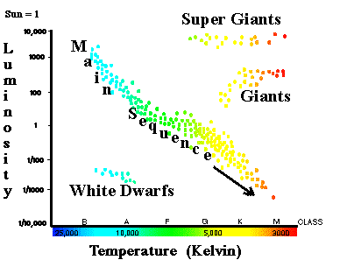
Danish astronomer Ejnar Hertzsprung and American astronomer Henry Norris Russell independently demonstrated the relationship between luminosity and color of stars in the early 1900s. This relationship is depicted in the now very familiar Hertzsprung-Russell diagram, which has revolutionized stellar astronomy. Our project seeks to find a similar relationship between the luminosity and color of active galactic nuclei (AGN).

Theoretically, at the heart of most, if not all, galaxies lies a massive black hole that continually pulls matter inward by gravity in a process called accretion. As the matter is accreted into the black hole, vast amounts of high-energy light are emitted. In some galaxies the center region produces as much or more light than all the stars in the galaxy do combined. These very luminous cores are called active galactic nuclei. The light from the core, typically peaking in the ultraviolet, is absorbed by the surrounding dust causing it to heat up and re-emit light at longer wavelengths with lower energy. This energy conversion gives rise to the color of the AGN.

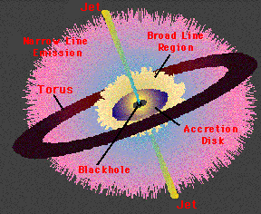
AGNs contain a concentration of dust in a ring around the black hole called a torus. According to the Unified Model of galaxies, when a galaxy is tilted toward earth such that we can see into the center of the ring, the UV light from around the black hole is nearly unobscured by dust and broad hydrogen emission lines can be seen in the spectra due to the intense speed of matter near the black hole. Galaxies in this orientation are classified as Type I galaxies. Type II galaxies are oriented in such a way that we cannot see into the ring and therefore the UV light is obscured and only narrow emission lines from the outer gases are visible. For this reason, we will be investigating only Type 1 galaxies.

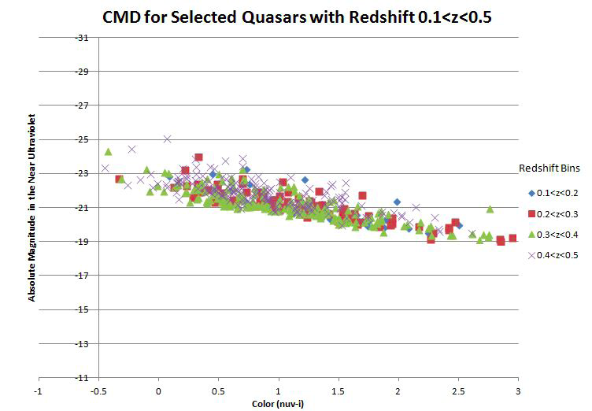
The 2012 NITARP team was successful in finding a trend in the UV luminosity and color of the AGN in Type I quasars. Quasars are galaxies containing AGN that are at least 100 times more luminous than the stars that surround them. Color was defined as the ratio of fluxes in the near ultraviolet (from Galaxy Evolution Explorer, GALEX) to the z band (from Sloan Digital Sky Survey, SDSS). The team found similar correlations to the UV magnitude when the r- and z- bands from SDSS were used to determine color. Our project will attempt to examine whether the trend remains the same for less luminous galaxies known as Seyferts.

The 2010 NITARP team also studied Seyfert galaxies in search of a similar color-magnitude correlation. The team found no evidence of a correlation between the UV color and the infrared luminosity of the AGN. We are hopeful that by studying Seyfert galaxies at the wavelengths used by the 2012 team, we will succeed in finding a correlation between color and magnitude of these AGN in the UV.

