NOTE: changes are highlighted in yellow. All references to Lori Allen’s poster have been changed to Allen et al (2011).

Young Stellar Objects in Bright Rimmed Clouds:
A NITARP Experience

Principal Investigator and Lead Teacher:
Chelen H. Johnson, Breck School, Minneapolis, MN
chelen.johnson@breckschool.org

Co-Investigators and Educators:
John Gibbs, Glencoe High School, Hillsboro, OR
gibbsj@hsd.k12.or.us

Russ Laher, Raytheon Spitzer Science Center, Caltech, Pasadena, CA
laher@ipac.caltech.edu

Mark Legassie, Spitzer Science Center, Caltech, Pasadena, CA
mark@ipac.caltech.edu

Marcella Linahan, Carmel Catholic High School, Mundelein, IL
mlinahan@carmelhs.org

Diane Sartore, Pine Ridge High School, Deltona, FL
dcsartore@gmail.com

Technical Contact and Supporting Scientist:
Dr. Luisa M. Rebull, Spitzer Science Center, Caltech, Pasadena, CA
rebull@ipac.caltech.edu

Abstract
Will write this after the rest of the paper is complete …

Science Background and Context: Star Formation
Few issues in astronomy are more fundamental than understanding stellar processes. Star formation has been, and will continue to be, the topic of vigorous investigations. Stars are born in nebulae, giant molecular clouds of gas and dust found in abundance within disk components of spiral galaxies. Star formation may be triggered in a molecular cloud that is already contracting by shock waves from a variety of sources including explosion of supernovae, ignition of a very hot nearby star, collisions with another molecular cloud, or density waves within spiral arms. A very large cloud typically contracts to form individual stars (perhaps hundreds or more). During the processes of accretion, self-gravitation, and differentiation, protostars are shielded within their nebula, leading to the characterization of nebulae as stellar nurseries. Theoretical models predict that these protostars must be very luminous and look like cool red stars, but are invisible in visible wavelengths. The dust cocoon absorbs most of the visible radiation surrounding the protostar and the nebula itself obscures the protostar from our view. The energy from the protostar warms the dust, which then re-radiates the energy from the protostar as infrared radiation. Thus, protostars are detectable within their nebula at infrared wavelengths. Excess infrared signatures may indicate the existence of an accompanying accretion disk. Jets from hidden protostars may also announce the presence of the still hidden protostar.

Bright Rimmed Clouds (BRCs) are clouds that have experienced compression due to an external ionization shock, which served to focus the neutral gas into compact globules (Migenesa et al 2008). These clouds generally have a radius of less than 0.5 pc, with an average mass near (or exceeding) 100 solar masses. Attention has turned to BRCs as potential loci for star formation, their speck globules and cometary globules present interesting sites for possible star formation. Whether external ionization shocks compress the neutral gas into compact globules or bright rims, the boundary between neutral gas and gas ionized by incident photons is thought to be rich in potential sites for star formation. Drawn from the surveys of Sugitani, Fukui, and Ogura (1991), Sugitani and Ogura (1994), and Allen et al (2011) imaged 32 of the closest bright-rimmed clouds located at estimated distances d < 1.2 kpc, finding young stellar objects in 75% of the clouds studied.

Using Spitzer Space Telescope Archival Data we propose to conduct further examinations of BRC 27 and BRC 34 to search for additional Young Stellar Objects. BRC 27 is located in the molecular cloud Canis Majoris R1. BRC 34 has a variety of features worthy of deeper examination: dark nebulae, molecular and IC clouds, emission stars, and IR sources. Allen et al (2011) found one Class I protostar in BRC 27 and BRC 34. Far more Class II T-Tauri stars were found in these same areas of the sky. Beyond that, these two BRCs have not been well studied. We have a few other targets that we could study instead, or in addition to, the targets discussed here if the analysis goes faster than anticipated. We would like to search for undiscovered young stellar objects (YSOs). We believe there are more YSOs to find in these BRCs using Spitzer Space Telescope archival data in a variety of wavelengths.

BRC 27. BRC 27 is a star-forming region located in the molecular cloud CMa R1 and is considered a type “A” bright rimmed cloud because of the moderate curvature of its morphology. The source of the shock front that triggered star formation in this region is still uncertain (Gregorio-Hetem 2009). In a survey of this star-forming region, 179 Hα-emission stars were identified by Wiramihardja (1986) using UBV photographic photometry. Sugitani, Fukui & Ogura (1991) identified a star cluster associated with BRC 27 in their catalog of bright-rimmed clouds with IRAS point sources and subsequent research by Sugitani, Tamura & Ogura (1995) showed elongation of the cluster members indicating that the star formation in BRC 27 was a triggered event. Using J, H, K_{S} photometry Soares and Bica (2002, 2003) determined the distance of 1.2 kpc and age 1.5 Myr of the stars in BRC 27. This distance measurement was consistent with the findings of Shevchenko (1999) who placed the distance at 1.05 ± 0.15 kiloparsecs. Recently Gregorio-Hetem et al (2009) surveyed a wide-field X-ray study of the CMa OB1/R1 star forming regions in an attempt to find low mass YSOs that may not have been detected previously. In their analysis they identified ~40 members near Z CMa and ~60 members near GU CMa which are both in the vicinity of BRC 27. As part of a survey of 44 bright-rimmed clouds, Morgan et al (2008) used submillimeter SCUBA observations and archival data from near-IR plus mid- to far-IR to identify a dense core in BRC 27. Using BVIC photometry Chauhan et al (2009) compared the ages of stars inside and outside the rims. As a result, they identified four BRC including BRC 27 that showed evidence of a radiation driven implosion.
BRC 34. BRCs exist at the edge of HII regions and are often produced by radiative-driven implosion (RDI). According to Morgan et al (2004) nearby massive stars shock the surrounding area to trigger star formation. The UV flux of nearby OB stars causes the BRC to collapse (Morgan 2004). Additionally, Morgan (2004) reports that recombination with the ionized boundary layer (IBL) allows the BRC to be seen at optical wavelengths. Sugitani et al 1991 (1991) classifies BRC based on their rim morphology: type A, B, and C with moderately curved, tightly curved, and cometary curved rims, respectively. We propose to examine young stellar objects (YSO) in BRC 34 with coordinates of 21 h 32 m 51.2s +38d08m43s and 0.75 kiloparsecs (Sugitani 1991). Sugitani et at classified BRC 34 as type A.

Table 1. Previously identified IRAS Point Sources within 10 arcminutes (SIMBAD).
Identifier | Dist (arcsec) | RA | DEC
IRAS 21319+5755 | 268.14 | 21 33 25.0 | +58 08 26
IRAS 21316+5751 | 283.31 | 21 33 10.2 | +58 04 43
IRAS 21320+5752 | 373.69 | 21 33 33.4 | +58 05 56
IRAS 21314+5802 | 429.35 | 21 32 55.5 | +58 15 51
IRAS 21320+5752 | 436.65 | 21 32.5 | +58 02
IRAS 21323+5800 | 578.04 | 21 33 52.0 | +58 14 04

Table 2. Previously identified stars within 10 arcminutes (SIMBAD).
Identifier | Class | Dist (arcsec) | RA | DEC
TYC 3975-82-1 | G8 | 380.45 | 21 33 38.069 | +58 07 19.42
HD 205510 | A3 | 439.13 | 21 33 41.7048 | +58 11 45.234
GSC 03975-00282 | K | 508.26 | 21 33 36.91 | +58 02 46.6
BD+57 2346 | K2 | 566.01 | 21 32 29.6670 | +58 17 42.840
Cl*Trumpler 37 KUN 170 |  | 567.55 | 21 33 17.02 | +57 59 53.7
Cl*Trumpler 37 KUN 307 |  | 590.18 | 21 34 05.29 | +58 07 38.8

Ogura et al (2002) using Hα grism spectroscopy and narrowband imaging found two Hα emission stars in BRC 34. These are identified in Table 3 and Figure 1. Object 1 has been confirmed in SIMBAD.

Table 3. Two H-alpha emission stars in BRC 34.
Identifier |  | Dist (arcsec) | RA | DEC
1 | 2MASS J21332921+5802508 | 463.43 | 21 33 29.21 | +58 02 50.9
2 |  |  | 21 33 55.8 | +58 01 18

Figure 1. Two H-alpha emission stars in BRC 34. (Ogura 2002)
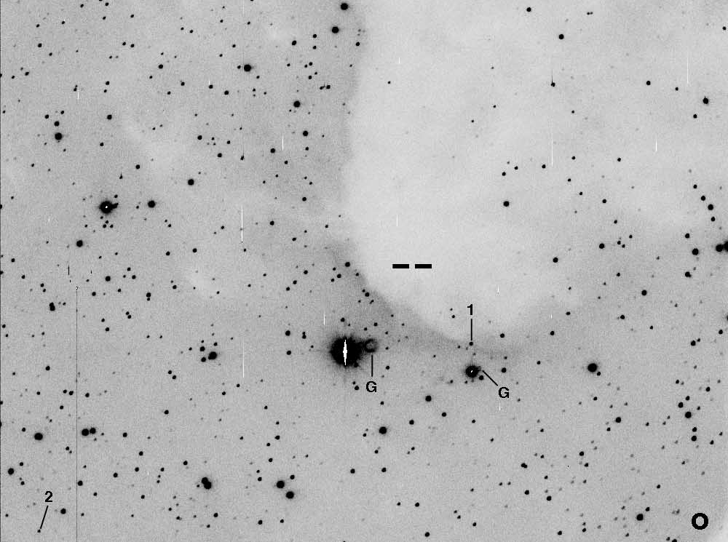

Morgan (2004) used archival data from IRA, NRAO/VLA Sky Survey (NVSS), Digitized Sky Survey (DSS) and the mid-course Space experiment (MSX) to characterize the IBL of BRC34. No 20-cm emission was associated with the rim of BRC 34. Valdettaro et al (2005) did not detect water maser emissions, indicative of YSOs, at 22.2 GHz. They surmised that the negative results were due to the emission from the heated dust near the head of the BRC. This might also be indicative of low-mass star formation. Morgan et al (2007) studied BRC 34 by using Submillimeter Common User Array (SCUBA) data and supplemented their findings with NASA/IPAC Infrared Science Archive (IRAS at 12, 25, 60 and 100 μm) and Two-Millimeter All-Sky Survey (2MASS) archival data. A search of the 2MASS catalog by Morgan (2007) found that BRC 34 did not include any T-Tauri stars nor any class I YSO candidates. They proposed that the lack of YSOs might be due to the protostellar core being at the early stages of evolution. Morgan et al (2009) observed CO spectra of BRC 34. As a result of this and previous work (Morgan 2004, 2007), Morgan eliminated BRC 34 as a good candidate for RDI suggesting that its evolution would not be affected by nearby OB stars.

Analysis Plan
Spitzer archival data from IRAC and MIPS will be the main focus of our research, augmented with data from 2MASS and MSX. Data for BRC 27 will originate from Spitzer program 30050 (reqkeys 17512192 and 17512448) while BRC34 data will originate from program 202 (reqkeys 6031616 and 6031872). See Figure 2 for visualization of BRC27 data using the Spitzer Planning and Observation Tool (Spot). Reference Figure 3 for visualization of BRC 34 data.
Figure 2. Spot visualization of BRC27 IRAC and MIPS data on a 25-micron view of the area. IRAC data is displayed in the blue and purple regions, while MIPS is shown in tan.
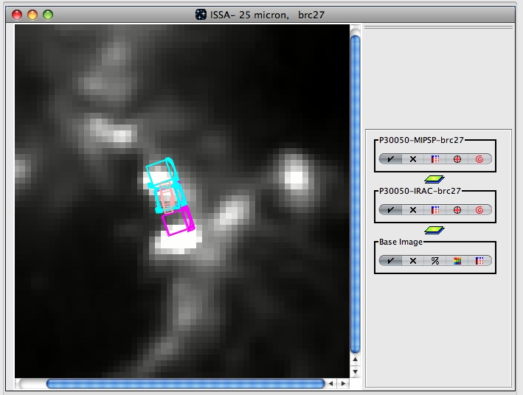
Figure 3. Spot visualization of BRC34 IRAC and MIPS data on a 25-micron view of the area. IRAC data is displayed in the blue and purple regions, while MIPS is shown in tan.
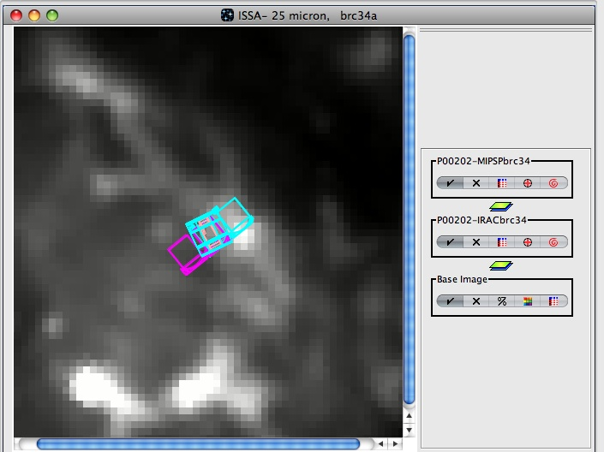

Our plan is to combine all available data and examine properties of previously known YSOs (Allen et al 2010), as well as look for new YSOs. To accomplish this, a well-known property of YSOs will be exploited -- namely, large near- and mid-infrared emissions from material surrounding young stars. Looking for excess emissions will be the main focus of the research, and Spitzer is excellent at detecting these emissions as well as any bipolar outflows. Using the combined data, we will generate and analyze various plots, including spectral energy distributions (SEDs), color-magnitude diagrams, and color-color diagrams to search for stars with infrared excesses.
We will generate mosaics of the BRC objects using MOPEX-Mosaics from Photometry data (Makovoz & Marleau 2005). For data reduction, the Aperture Photometry Tool (APT) will assist us in obtaining photometry values. These tools will allow our team to conduct flux analyses as well as spatial analyses and detailed visual observations. The resultant data will be analyzed further using a spreadsheet program (MS Excel). Excel will allow students to generate color diagrams and SEDs with the data to test infrared wavelength theories of identifying and classifying young stellar objects.

Education and Outreach
Starting with a general introduction to the physical properties of light, students and teachers will collaborate to synthesize observations across the EM spectrum. They will compare images obtained by IRAC, MIPS and IRAS to learn about spatial resolution. Evidence will be presented to help students understand how the universe is changing, how stars and planets are forming, and how stars evolve from birth to eventual death. Combining images at different wavelengths, students will be able to produce false-color images that enhance the features of young stellar objects and the ISM composition and structures.

A key initiative in science education is authentic research. Using archival Spitzer data in this project allows our students the experience to assume an active role in the process of project development, teamwork, data collection and analysis, interpretation of results, and formal scientific presentations. They will learn about the instrumentation used in infrared astronomy and the necessity of space-based telescopes. Students and teachers will use spreadsheet and graphing programs to generate color-color plots and color-magnitude diagrams to determine stellar properties. These activities will be age-appropriate and will be shared with other teachers through educational presentations at state, regional and national conferences.

Communication is an important tool in science education. Modeling the collaboration of scientists across the world, students will use the CoolWiki to post their queries and hold on-line discussions about their analysis methods and subsequent results. The CoolWiki is designed to provide a place for teachers, students, and scientists to interact and share the materials they've developed, work on new materials, and collaborate on current projects. The wiki also provides a resource for other teachers to learn how to use the materials we've developed. The wiki is a dynamic place, constantly changing and growing.

Team Spitzer at Breck School. Similar to previous NITARP/Spitzer projects, a small cadre of Breck School juniors and seniors will work together on this BRC project. Beginning with short tutorials on the general principles of star formation, scientific articles will be read and discussed in weekly "brown-bag discussions." Once the students feel comfortable with the material, the team will be divided into pairs to work cooperatively on the data analysis.

Glencoe Astronomy at Glencoe High School. Glencoe High School students ranging from sophomores to seniors will work together on this BRC project. There are currently seven students starting this project and additional students are anticipated. Students will be given weekly readings that will be discussed during our meetings each Thursday morning. We will begin with the basic principles of stellar evolution with an emphasis on star formation. Resources will include tutorials posted on the CoolWiki website and scientific articles relevant to the BRC project. Students will work together in teams during the data analysis and continue to meet to discuss their work.

Carmel Catholic High School students will participate in the Spitzer research program as an extracurricular activity. They will meet once a week for two to four hours or as needed. Students will read a variety of resources and participate in activities to learn about the history of astronomy and stellar evolution. They will become proficient in a variety of image processing software programs and share their research findings at local outreach events at the middle school, high school, and community levels.

The Pine Ridge Astronomy Team has a history of participation in big projects; our first project was with the Lunar Prospector in 1998. Fortuitously, as one project winds down, another comes along to replace it. Even when we do not have an organized campaign, the sky always presents something different for us to examine. The team meets during Wednesday lunchtime meetings. Team members organize Night Labs and Morning Labs to take advantage of good viewing opportunities as they arise during the school year. They also participate in community outreach activities: science night at local elementary schools, Relay for Life, and other local events. Currently, students are exploring web sites and reading articles in preparation for their Spitzer work and are anxious to get started!

Bibliography
Allen L., et al. American Astronomical Society, AAS Meeting #217, #258.15;
Bulletin of the American Astronomical Society, Vol. 43, 2011.
Chauhan N, Pandey A.K., Ogura K., Ojha D.K., Bhatt B.C., Ghosh S.K., Rawat
P.S., 2009, MNRAS, 396, 964.
Gregorio-Hetem J., Montmerle T., Rodrigues C. V., Marciotto E., Preibisch T., Zinnecker H., 2009, A&A, 2009, 506, 711.
Makovoz D., Marleau F. R., 2005, PASP, 117, 1113.
Morgan L. K., Thompson M. A., Urquhart J. S., White G. J., 2008, A&A, 477, 557.
Morgan L. K., Thompson M. A., Urquhart J. S., White G. J., Mio J., 2004, A&A,
426, 535.
Morgan L. K., Urquhart J. S., Thompson M. A., 2009, MNRAS, 400, 1726.
Ogura K., Sugitani K., Pickles A., 2002, AJ, 123, 2597.
Shevchenko V. S., Ezhkova O. V., Ibrahimov M. A., van den Ancker M. E., Tjin A
Djie H. R. E., 1999, MNRAS, 310, 210.
Soares J.B., Bica E., 2002, A&A, 388, 172.
Soares J.B., Bica E., 2003, A&A, 404, 217.
Sugitani K., Fukui Y., Ogura K., 1991, ApJS, 77, 59 (SFO91).
Sugitani K., Ogura K., 1994, ApJS, 92, 163.
Sugitani K., Tamura M., Ogura K., 1995, ApJ, 455, L39.
Valdettaro R., Palla F., Brand J., Cesaroni R., 2005, A&A, 443, 535.
Wiramihardja S.D., Kogure T., Nakano M. and Yoshida S., 1986, PASJ, 38, 395.

Questions about Bib (from John)…
The three references in red I have not added yet because I am not certain about the references. I could not find Miganesa et al 2008 and the only article I found for Allen 2011 had Allen as the second author and Morgan et al 2007 was third. I have listed the articles below and I have emailed Diana and Marcella for clarification.

Migenesa et al 2008

Morgan et al (2007)
Urquhart J. S., Thompson M. A., Morgan L. K., Pestalozzi M. R., White G.J., Muna D. N., 2007, A&A , 467, 1125
2007A&A...467.1125U
Astron. Astrophys., 467, 1125-1137 (2007)
A tale of two cores: triggered massive star formation in the bright-rimmed cloud SFO 75.
URQUHART J.S., THOMPSON M.A., MORGAN L.K., PESTALOZZI M.R., WHITE G.J. and MUNA D.N.

