Plotting a Color Magnitude Diagram for Active Galactic Nuclei
Educator Team: Nicole Granucci, Theresa Paulsen, Thomas Rutherford
Mentor Teacher: John Blackwell
Science Mentor: Varoujan Gorjian

Abstract
A color magnitude diagram will be produced for Type I Active Galactic Nuclei (0.1 < z < 0.5) using data from the Sloan Digital Sky Survey and the Galaxy Evolution Explorer Satellite. The UV luminosity and color index (NUV-i) of Type I Seyferts will be plotted. It is expected that this data will demonstrate a correlation between the luminosity and the color (temperature) of the accretion disk in AGN. This data will be added to a similar plot of Type I quasars produced by the 2012 NITARP team, to generate a more complete color magnitude diagram for AGN.

Background

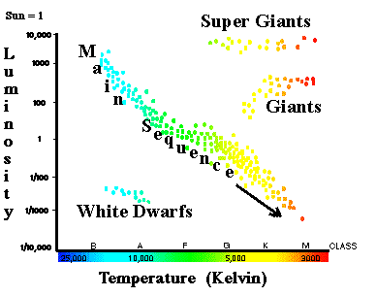
Danish astronomer Ejnar Hertzsprung and American astronomer Henry Norris Russell independently demonstrated the relationship between luminosity and color of stars in the early 1900s. This relationship is depicted in the familiar Hertzsprung-Russell diagram, which has revolutionized stellar astronomy. Our project seeks to find a similar relationship between the luminosity and color of active galactic nuclei (AGN).

Theoretically, at the heart of most, if not all, galaxies lies a massive black hole that continually pulls matter inward by gravity in a process called accretion. As the matter is accreted into the black hole, vast amounts of high-energy light are emitted. In some galaxies, the center region produces as much or more light than all the stars in the galaxy do combined. These very luminous cores are called active galactic nuclei. The light from the core, typically peaking in the ultraviolet, is absorbed by the surrounding dust causing it to heat up and re-emit light at longer wavelengths with lower energy. This energy conversion gives rise to the color of the AGN.

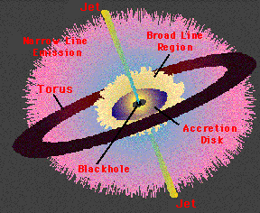
AGNs contain a concentration of dust in a ring around the accretion disk called a torus. According to the Unified Model of galaxies, when a galaxy is tilted toward earth such that we can see into the center of the ring, the UV light from around the black hole is nearly unobscured by dust and broad hydrogen emission lines can be seen in the spectra due to the intense speed of matter near the black hole. Galaxies in this orientation are classified as Type I galaxies. Type II galaxies are oriented in such a way that we cannot see into the ring and therefore the UV light is obscured and only narrow emission lines from the outer gases are visible.
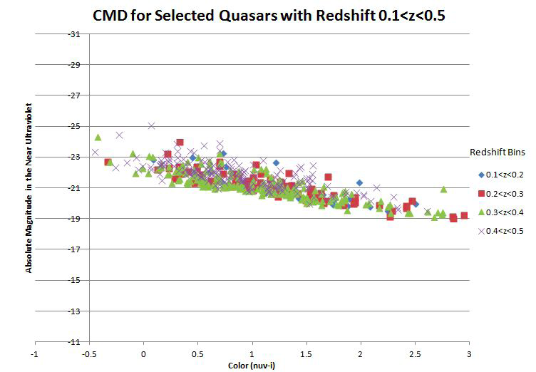
The 2012 NITARP team was successful in finding a trend in the UV luminosity and color of the AGN in Type I quasars. Quasars are galaxies containing AGN that are at least 100 times more luminous than the stars that surround them. Color was defined as the ratio of fluxes in the near ultraviolet (from Galaxy Evolution Explorer, GALEX) to the z band (from Sloan Digital Sky Survey, SDSS). The team found similar correlations to the UV magnitude when the r- and z- bands from SDSS were used to determine color.

The 2010 NITARP team also studied Seyfert galaxies in search of a similar color-magnitude correlation. The team found no evidence of a correlation between the color and the infrared luminosity of the AGN. We are hopeful that by studying Seyfert galaxies at the wavelengths used by the 2012 team, we will succeed in finding a correlation between color and magnitude of these AGN in the UV.

Science Goals
We intend to:
- Investigate only Type 1 Seyfert galaxies to avoid obscuration of the accretion disk by the dusty torus.
- Use photometry data archived in the NASA Extragalactic database (NED) from SDSS and GALEX.
- Determine the color and luminosity of the accretion disk within the Type I Seyferts using the same method as the 2012 team used to produce a color magnitude diagram for quasars. This will allow both data sets to be merged to produce a more complete color magnitude diagram for Type I AGN.

Education Goals
Theresa Paulsen intends to:
- Work with her students to share their NITARP experience with the entire student body, staff, and community in Mellen. They will be able to reach people throughout the community through our elementary science shows, and family science night.
- Lead workshops for educators at the regional and state level including a regional teacher in-service and the annual conventions for the Wisconsin Society of Science Teachers (WSST).
- Prepare an article about the experience for the local newspapers, the school web page, and the WSST newsletter.
- Keep a blog of the experience on the her “NASA Adventures” page of her classroom website: www.digginscience.weebly.com
- Prepare a podcast about the experience for our classroom YouTube channel: http://www.youtube.com/user/DigginScience98
- Present to general audiences at a local restaurant that hosts a monthly science café, and at the Apostle Islands National Lakeshore where science professionals frequently discuss their research with the public.

