Young Stellar Objects in Bright Rimmed Clouds:
A NITARP Experience

Principal Investigator and Lead Teacher:
Chelen H. Johnson, Breck School, Minneapolis, MN
chelen.johnson@breckschool.org

Co-Investigators and Educators:
John Gibbs, Glencoe High School, Hillsboro, OR
gibbsj@hsd.k12.or.us

Marcella Linahan, Carmel Catholic High School, Mundelein, IL
mlinahan@carmelhs.org

Diane Sartore, Pine Ridge High School, Deltona, FL
dcsartore@gmail.com

Mark Legassie, Spitzer Science Center, Caltech, Pasadena, CA
mark@ipac.caltech.edu

Russ Laher, Raytheon Spitzer Science Center, Caltech, Pasadena, CA
laher@ipac.caltech.edu

Technical Contact and Supporting Scientist:
Dr. Luisa M. Rebull, Spitzer Science Center, Caltech, Pasadena, CA
rebull@ipac.caltech.edu

Abstract
Found near the edges of HII regions, bright-rimmed clouds (BRCs) are thought to be home to triggered star formation. Using Spitzer Space Telescope archival data, we will investigate BRC 27 and BRC 34 to search for previously known and new additional young stellar objects (YSOs). BRC 27 is located in the molecular cloud Canis Majoris R1, a known site of star formation. BRC 34 has a variety of features worthy of deeper examination: dark nebulae, molecular clouds, emission stars, and IR sources. Beyond the unpublished preliminary analysis found in Allen et al. (2011), these two BRCs have not been studied in detail. Our plan is to combine all available data, compare archival data to what is published in the literature, and examine properties of previously known YSOs as well as look for new YSOs. To accomplish this, we will search for YSOs using infrared excess, namely, large near- and mid-IR emissions originating from material surrounding young stars.

Science Background and Context: Star Formation
Few issues in astronomy are more fundamental than understanding how stars form and evolve. Star formation has been, and will continue to be, the topic of vigorous investigations. Stars are born in nebulae, giant molecular clouds of gas and dust found in abundance within disk components of spiral galaxies, including our own. Star formation may be triggered in a molecular cloud by shock waves from a variety of sources including explosion of supernovae, ignition of a very hot nearby star, collisions with another molecular cloud, or density waves within spiral arms (Klein 1980, Sandford 1982, Bertoldi 1989). A very large cloud typically contracts to form hundreds (or more) individual stars. During their formation process, protostars are shielded within their nebula, leading to the characterization of nebulae as stellar nurseries. The earliest phases of a protostar’s life are spent deep inside their natal dust cocoon, which absorbs most of the visible radiation produced by the protostar and obscures the protostar from view in the optical. The energy from the protostar warms the dust, which then re-radiates the energy from the protostar as infrared (IR) radiation. Thus, protostars are detectable within their circumstellar material at infrared wavelengths. (Sugitani et al 1991) Jets from hidden protostars may also announce the presence of the still hidden protostar.

Bright Rimmed Clouds (BRCs) exist at the edge of HII regions. They are clouds that have experienced compression (and illumination) due to an external ionization shock from nearby massive stars, which served to focus the neutral gas into compact globules (Morgan et al. 2004, Valdetarro et al. 2008) and possibly trigger star formation. Additionally, Morgan (2004) reports that recombination with the ionized boundary layer allows the BRC to be seen at optical wavelengths, hence “bright rimmed.” These clouds generally have a radius of less than 0.5 parsecs, with an average mass about 100 solar masses. Attention has turned to BRCs as potential loci for star formation. Since the ionization front is compressing the gas and dust, the region near the boundary between neutral gas and gas ionized by incident photons is thought to be rich in potential sites for star formation. Sugitani et al. (1991) classify BRCs based on their rim morphology: type A, B, and C with moderately curved, tightly curved, and cometary curved rims, respectively. Using Spitzer’s Infrared Array Camera (IRAC), Allen et al. (private communication 2011) imaged 32 of the closest BRCs located at estimated distances d < 1.2 kiloparsecs (drawn from the surveys of Sugitani et al. 1991 and Sugitani and Ogura 1994), finding young stellar objects in 75% of the clouds studied.

Using Spitzer Space Telescope archival data, we propose to conduct further detailed examinations specifically of BRC 27 and BRC 34 to search for previously known and new additional young stellar objects (YSOs). BRC 27 is located in the molecular cloud Canis Majoris R1, a known site of star formation. BRC 34 has a variety of features worthy of deeper examination: dark nebulae, molecular clouds, emission stars, and IR sources. In a preliminary analysis, Allen et al. (2011) found both Class I and Class II YSOs in these BRCs. Beyond that, these two BRCs have not been studied in detail. We will investigate these regions in detail using Spitzer Space Telescope archival data in a variety of wavelengths. We will look for stars with apparent infrared excesses, indicative of a circumstellar disk and therefore youth. We will compare these objects to those identified via other methods in the literature. We will assess which IR-selected YSO candidates are new or rediscoveries of previously known YSOs. Because there are previously identified YSOs in this region, and because the previous YSO searches were relatively shallow, we believe there are new YSOs to find in these BRCs. We now discuss what is known about these two targets. We have a few other targets that we can study instead, or in addition to, the targets discussed here if our analysis goes faster than anticipated.

BRC 27. BRC 27 is a star-forming region located in the molecular cloud CMa R1 (07h04m07.8s -11d16m43s) and is considered a type “A” bright-rimmed cloud because of the moderate curvature of its morphology. The source of the shock front that triggered star formation in this region is still uncertain (Gregorio-Hetem et al. 2009). In a survey of this larger star-forming region, 179 Hα-emission stars were identified by Wiramihardja et al. (1986) using UBV photographic photometry. Sugitani et al. (1991) identified a star cluster associated with BRC 27 in their catalog of bright-rimmed clouds with IRAS point sources. Subsequent research by Sugitani et al. (1995) showed elongation of the distribution of cluster members suggesting that the star formation in BRC 27 was a triggered event. Using JHK_{S} photometry, Soares and Bica (2002, 2003) determined a distance of 1.2 kiloparsecs and age 1.5 Myr of the stars in BRC 27. This distance measurement was consistent with the findings of Shevchenko (1999) who placed the distance at 1.05 ± 0.15 kiloparsecs. Recently Gregorio-Hetem et al. (2009) reported on a wide-field X-ray study of the CMa OB1/R1 star forming region in an attempt to find low mass YSOs that may not have been detected previously. In their analysis, they identified approximately 40 members near Z CMa and approximately 60 members near GU CMa which are both in the vicinity of BRC 27. As part of a survey of 44 bright-rimmed clouds, Morgan et al. (2008) used Submillimeter Common User Bolometer Array (SCUBA) observations and archival data from near-IR plus mid- to far-IR to identify a dense core in BRC 27. Using BVI_{C} photometry, Chauhan et al. (2009) compared the ages of stars inside and outside the rims. As a result, they concluded that it showed evidence of a radiation driven implosion. We note here for completeness that Chauhan et al. analyzed the archival IRAC (but not MIPS) data for BRC 27, but selected their YSOs based on near-IR JHK colors. We will select our YSO candidates based on mid-IR IRAC *and* MIPS colors, so we expect to find a different set of YSO candidates. Even if we do not find any new candidate YSOs, we can compare the IR properties of, for example, the young stars selected via the H survey as compare to those selected via the X-ray survey.
BRC 34. BRC 34 is located at coordinates of 21 h 32 m 51.2s +58d08m43s and is thought to be at 0.75 kiloparsecs (Sugitani 1991). Sugitani et al. (1991) classified BRC 34 as type A. Using Hα grism spectroscopy and narrowband imaging, Ogura et al. (2002) found two Hα emission stars in BRC 34. These are identified in Table 1 and Figure 1.

Table 1. Two H-alpha emission stars in BRC 34. (Ogura 2002)
Identifier |  | RA | DEC
BRC 34-1 | 2MASS J21332921+5802508 | 21 33 29.21 | +58 02 50.9
BRC 34-2 |  | 21 33 55.8 | +58 01 18

Figure 1. Two H-alpha emission stars in BRC 34. (Ogura 2002)
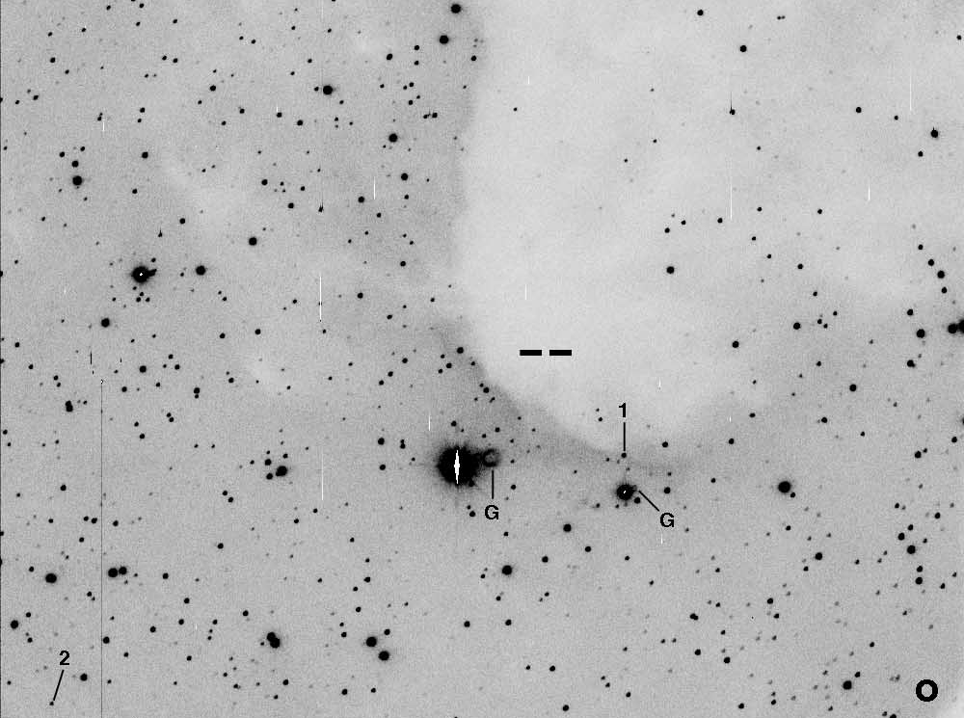

Morgan (2004) used archival data from IRAS, NRAO/VLA Sky Survey (NVSS), Digitized Sky Survey (DSS) and the mid-course Space experiment (MSX) to characterize the boundary layer of BRC34. No 20-cm emission was associated with the rim of BRC 34. Valdettaro et al. (2005) did not detect water maser emissions indicative of YSOs at 22.2 GHz. They surmised that the negative results were due to the emission from the heated dust near the head of the BRC. This might also be indicative of low-mass star formation. Morgan et al. (2008) studied BRC 34 using SCUBA data and supplemented their findings with NASA/IPAC Infrared Science Archive data – IRAS at 12, 25, 60 and 100 μm and Two-Millimeter All-Sky Survey (2MASS) at JHK_{s} bands. A search of the 2MASS catalog by Morgan (2008) found that BRC 34 did not include any T-Tauri stars nor any class I YSO candidates. They proposed that the lack of YSOs might be due to the protostellar core being at the early stages of evolution. Morgan et al. (2009) observed CO spectra of BRC 34. As a result of this and previous work (Morgan 2004, 2008), BRC 34 was eliminated as a good candidate for radiation-driven implosion, suggesting that its evolution would not be affected by nearby OB stars. We will investigate the properties of this object with Spitzer archival data, and compare the number of YSO candidates found here with our other target, BRC 27. The literature suggests that we will find fewer YSO candidates here than in BRC 27.

Analysis Plan
Spitzer archival data from the Infrared Array Camera (IRAC) and the Multiband Imaging Photometer for Spitzer (MIPS) will be the main focus of our research, augmented with data from the Two-Micron All-Sky Survey (2MASS) the Midcourse Space Experiment (MSX), and the Widefield Infrared Survey Explorer (WISE), when those data become available in Spring 2011. Spitzer data for BRC 27 will originate from Spitzer program 30050 (AORKEYs 17512192 and 17512448) while BRC34 data will originate from program 202 (AORKEYs 6031616 and 6031872). See Figure 2 for visualization of BRC 27 data using the Spitzer Planning and Observation Tool (Spot), and Figure 3 for visualization of BRC 34 data.
Figure 2. Spot visualization of BRC27 IRAC and MIPS data on a 25-micron view of the area. IRAC data are displayed in the blue and purple regions, while MIPS are shown in tan.
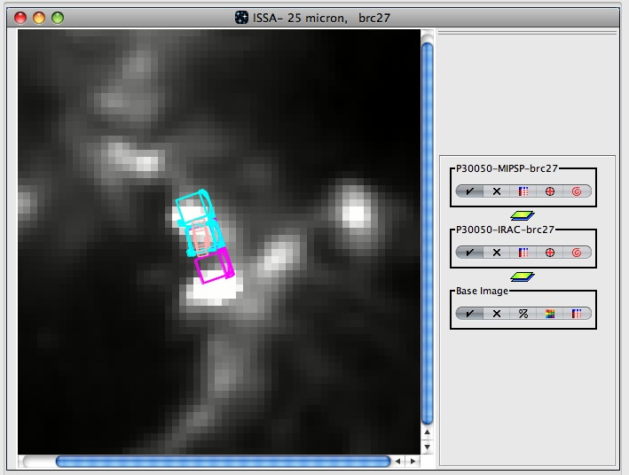

Figure 3. Spot visualization of BRC34 IRAC and MIPS data on a 25-micron view of the area. IRAC data are displayed in the purple and smaller blue regions, while MIPS are shown in tan and the larger blue box.
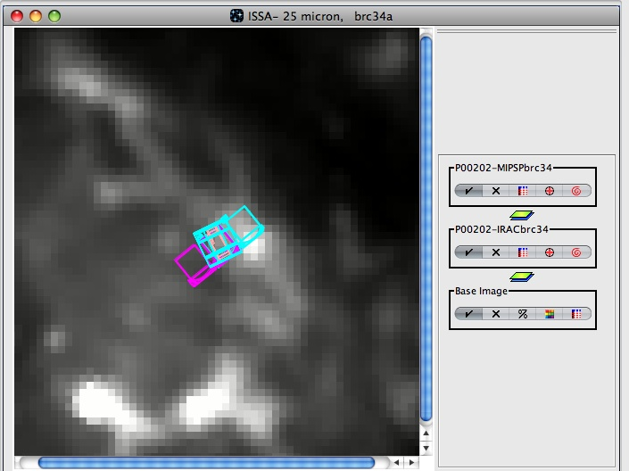

Our plan is to combine all available data, obtain photometry, compare to what is known in the literature, and examine properties of previously known YSOs (as summarized for each cloud above), as well as look for new YSOs. To accomplish this, a well-known property of YSOs will be exploited -- namely, large near- and mid-IR emissions from material surrounding young stars. Looking for YSOs using IR excess will be the main focus of the research, and Spitzer is excellent at detecting these emissions, as well as any bipolar outflows. Using the combined data, we will generate and analyze various plots, including spectral energy distributions (SEDs), color-magnitude diagrams, and color-color diagrams to search for stars with infrared excesses.
We will either use the pipeline mosaics or generate our own mosaics of the BRCs using MOPEX (Makovoz & Marleau 2005). For photometry, we will use a combination of MOPEX and the Aperture Photometry Tool (APT). We will collect the photometry in an MS Excel spreadsheet, which will allow us to convert between flux densities and magnitudes, generate color-color and color-magnitude diagrams, and SEDs with the data to identify and classify young stellar objects.

Education and Outreach
Starting with a general introduction to the physical properties of light, students and teachers will collaborate to synthesize observations across the EM spectrum. They will compare images obtained by IRAC, MIPS, MSX, IRAS, 2MASS, and WISE to learn about spatial resolution. Evidence will be presented to help students understand how the universe is changing, how stars and planets are forming, and how stars evolve from birth to eventual death. Combining images at different wavelengths, students will be able to produce false-color images that enhance the features of young stellar objects and the interstellar medium composition and structures.

A key initiative in science education is authentic research. Using archival Spitzer data in this project allows our students the experience of assuming an active role in the process of project development, teamwork, data collection and analysis, interpretation of results, and formal scientific presentations. They will learn about the instrumentation used in infrared astronomy and the necessity of space-based telescopes. Students and teachers will use spreadsheet and graphing programs to generate color-color plots and color-magnitude diagrams to determine stellar properties. These activities will be age-appropriate and will be shared with other teachers through educational presentations at state, regional and national conferences.

Communication is an important tool in science education. Modeling the collaboration of scientists across the world, students will use the CoolWiki to post their queries and hold on-line discussions about their analysis methods and subsequent results. The CoolWiki is designed to provide a place for teachers, students, and scientists to interact and share the materials they've developed, work on new materials, and collaborate on current projects. The wiki also provides a resource for other teachers to learn how to use the materials we've developed. The wiki is a dynamic place, constantly changing and growing.

Team Spitzer at Breck School (C. Johnson). Similar to previous NITARP/Spitzer projects, a small cadre of Breck School juniors and seniors will work together on this BRC project. Beginning with short tutorials on the general principles of star formation, scientific articles will be read and discussed in weekly "brown-bag discussions." Once the students feel comfortable with the material, the team will be divided into pairs to work cooperatively on the data analysis. The Breck students will collaborate with other CG4 Team members to produce a scientific poster and an educational poster to be presented at the January 2012 AAS conference.

Glencoe Astronomy at Glencoe High School (J. Gibbs). Glencoe High School students ranging from sophomores to seniors will work together on this BRC project. There are currently seven students starting this project and additional students are anticipated. Students will be given weekly readings that will be discussed during our meetings each Thursday morning. We will begin with the basic principles of stellar evolution with an emphasis on star formation. Resources will include tutorials posted on the CoolWiki website and scientific articles relevant to the BRC project. Students will work together in teams during the data analysis and continue to meet to discuss their work.

Carmel Catholic High School (M. Linahan). Students will participate in the Spitzer research program as an extracurricular activity. They will meet once a week for two to four hours or as needed. Students will read a variety of resources and participate in activities to learn about the history of astronomy and stellar evolution. They will become proficient in a variety of image processing software programs and share their research findings at local outreach events at the middle school, high school, and community levels.

Pine Ridge Astronomy Team (D. Sartore). Students have been organized around authentic research and community outreach. Each research project provides skills and analytical resources far beyond those normally encountered in a high school setting. The team meets for Wednesday lunchtime sessions and evening meetings. Currently students are exploring web sites and reading articles in preparation for their Spitzer work. The team meets for lunchtime sessions and evening labs. Students who attend summer training will share their newly acquired skills with other team members during the ensuing school year. Students will present their work and compete with projects (based on results) in a variety of academic settings.

Bibliography
Allen L., et al. 2011, American Astronomical Society, BAAS, 43, 258.15.
Bertoldi F., 1989, ApJ, 346, 735.
Chauhan N, Pandey A.K., Ogura K., Ojha D.K., Bhatt B.C., Ghosh S.K., Rawat
P.S., 2009, MNRAS, 396, 964.
Gregorio-Hetem J., Montmerle T., Rodrigues C. V., Marciotto E., Preibisch T.,
Zinnecker H., 2009, A&A, 2009, 506, 711.
Klein R., Sandford M., Whitaker R., 1980, SSRV, 27, 275.
Makovoz D., Marleau F. R., 2005, PASP, 117, 1113.
Morgan L. K., Urquhart J. S., Thompson M. A., 2009, MNRAS, 400, 1726.
Morgan L. K., Thompson M. A., Urquhart J. S., White G. J., 2008, A&A, 477, 557.
Morgan L. K., Thompson M. A., Urquhart J. S., White G. J., Mio J., 2004, A&A,
426, 535.
Ogura K., Sugitani K., Pickles A., 2002, AJ, 123, 2597.
Sandford M., Whitaker R., Klein R., 1982, ApJ, 260, 183.
Shevchenko V. S., Ezhkova O. V., Ibrahimov M. A., van den Ancker M. E., Tjin A,
Djie H. R. E., 1999, MNRAS, 310, 210.
Soares J.B., Bica E., 2003, A&A, 404, 217.
Soares J.B., Bica E., 2002, A&A, 388, 172.
Sugitani K., Fukui Y., Ogura K., 1991, ApJS, 77, 59.
Sugitani K., Ogura K., 1994, ApJS, 92, 163.
Sugitani K., Tamura M., Ogura K., 1995, ApJ, 455, L39.
Valdettaro R., Migenes V., Trinidad M.A., Brand J., Palla F., 2008, ApJ, 675, 1352.
Valdettaro R., Palla F., Brand J., Cesaroni R., 2005, A&A, 443, 535.
Wiramihardja S.D., Kogure T., Nakano M., Yoshida S., 1986, PASJ, 38, 395.

