CWAYS – Cool, WISE, and Young Stars;
NITARP search for YSOs using WISE data

Co-Investigators and Educators:

Peggy Piper , Lincoln-Way North High School, Frankfort, IL
peggypiper@yahoo.com

Jacqueline Barge , Walter Payton College Prep High School, Chicago, IL
jbcbarge@sbcglobal.net

Robert Bonadurer , Daniel M. Soref Planetarium at the Milwaukee Public Museum, Milwaukee, WI
bonadurer@mpm.edu

Debbie French , New Philadelphia High School, New Philadelphia, OH
frenchd@npschools.org

Lauren Novatne , Reedley College, Reedley, CA
laurennovatne@comcast.net

Russ Laher, Spitzer Science Center, Caltech, Pasadena, CA
laher@ipac.caltech.edu

Mark Legassie , Raytheon and Spitzer Science Center, Caltech, Pasadena, CA
mark@ipac.caltech.edu

With help from Dr. JD Armstrong (LCOGT) jd@ifa.hawaii.edu and Dr. Babar Ali (IPAC) babar@ipac.caltech.edu

Technical Contact and Support Scientist:
Dr. Luisa Rebull, Spitzer Science Center, Caltech, Pasadena, CA
rebull@ipac.caltech.edu

Abstract

Science Background and Context: BRCs and YSOs

Enormous clouds of gas and dust serve as the birthing places of stars in galaxies throughout our universe including the origin of own star and solar system.. While the exact mechanisms of star birth and evolution are not clearly understood, it is believed that stars are conceived either through gravitational factors that bring together large enough masses to result in fusion, or they are more dramatically triggered via outside energy sources.

Star formation can occur in regions of dense gas and dust called cold dark nebulae. The temperatures of these nebulae are approximately 10K to 100K (Maoz, 2007). The low kinetic energy of the gas and dust particles allows them to form clumps which gradually increase in size. This mass increase causes an increase in gravitational attraction of the particles in the cloud, which in turn causes more mass to fall on the clump, eventually forming a protostar. This process could be occurring in multiple regions in the dust cloud, at various stages and rates, producing from one to hundreds of thousands of protostars, depending on the size and mass of the dust cloud.

Bright rimmed clouds (BRCs) are a type of cold dark nebula with “bright rims” that can be seen at optical due to the effected of energy from nearby massive stars. They consist of a denser head that appears as a bright rim and less dense tail region (Sugitani et al, 1991). They are associated with HII regions that are approximately 10⁶ yrs old (Sugitani et al, 1991). BRCs may have been dense regions in a larger molecular cloud that were pushed outward by UV radiation emitted from O or B type stars (Sugitani et al, 1991). While BRCs are considered densely packed with dust in the astronomical sense, Maoz presents a comparison that these clouds, “are many orders of magnitude lower than the density of the best vacua achievable in the laboratory” (Maoz, 2007 pg. 114). The gas and dust are excited by the UV radiation emitted from O or B type stars associated with the dust cloud (Sugitani et al, 1991). Star formation is most likely triggered by the UV radiation and strong stellar winds from the associated O and B type stars which compress and ionize the material (Rebull, et al, 2011).

BRCs also provide a glimpse of star formation at different stages, depending on the location of the YSOs. Young stars that are very bright IR emitters are typically located near the head of the cloud, and bluer, older stars are located closer to the O or B type star at the tail. This suggests an evolutionary transition in the cloud known as small-scale sequential star formation (Beltrán, et al, 2009).
Bright-rimmed clouds are classified based on the shape of the following three categories; Type A has a moderately curved head, Type B has a head that is very curved, and Type C has a “cometary rim” (Sugitani et al, 1991). The curvature is defined as the ratio between the cloud length, l, and the width, w (Sugitani et al, 1991). There is no difference reported in the amount of star formation based on shape.

The purpose of this study is to identify new young stellar objects (YSOs) in BRC 27, BRC 34, and BRC 38 and to compare these results to previously identified young stellar objects in these regions. This research is an extension of the work done on BRC 27 and 34 by the Johnson et al. (2012 -- a 2011 NITARP team). This new research will focus primarily on the perimeter regions of BRC 27 and 34, which were not studied by Johnson et al. (2012 -- a 2011 NITARP team). In addition to BRC 27 and 34, BRC 38 will be studied in its entirety. We will use soon to be released WISE data along with archival data from the Spitzer Space Telescope and existing data from other sources. Using IR excess as an indication of youth, we will identify candidate young stars and compare them to objects identified in the literature. While many of our YSO candidates will already have been identified in the literature, we expect to find additional YSOs in the larger WISE footprint around BRC 27 and 34, as well as the less extensively studied BRC 37.

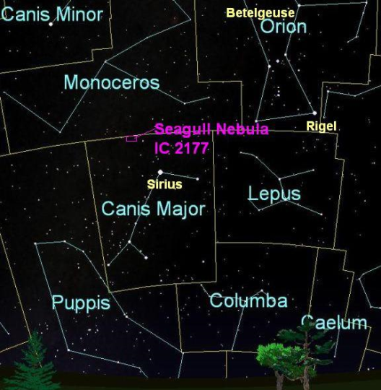
BRC 27 is a star forming region within the molecular cloud CMa R1, located at 07h03m39s -11d23m43s. This star forming region is believed to be a Radiation Driven Implosion (RDI) morphology, although what triggered the star formation is not certain at this time (Gregorio-Hetem et al, 2009). Previous works have identified stars using various techniques and different sources. Wiramihardja et al in 1986 used UBV photographic photometry, Sugitani et al in 1991 used IRAS sources. Soares and Bica in 2002 and 2003 determined a distance of 1.2 parsecs and an age of 1.5 Myr for the stars in BRC 27. The distance was consistent with the findings of Schevchenko in 1999. A wide field X-ray study of the CMa OB1/ R star forming region done by Gregorio- Hetem et al. (2009) was conducted to find low mass YSOs that may have been previously undetected. Chauhan et al in 2009 used BVIc photometry to compare the ages of stars inside and outside the rims. They suggest that there is evidence of an RDI mechanism. We note that Chauhan et al used archival IRAC, but not MIPS data, and moreover did not use the IRAC data as a primary mechanism to select YSO candidates; they used near-IR JHK colors to identify candidates. Johnson et al (2012 - NITARP 2011 team) and Rebull et al. (2012, in prep) used the mid-IR IRAC and MIPS colors to search for YSOs in a ~5'x5' footprint. They identified IR excesses around 21/33 previously-known YSO candidates and identified 19 entirely new YSO candidates. We will use WISE photometric data to survey a larger region (~10-15 arcmin diameter) around this relatively small ~5'x5' 4-band IRAC footprint from Spitzer to (a) look for IR excesses around previously-identified YSO candidates, and (b) look for new YSO candidates using the WISE bands. Because there are several prior shallow wide-field studies in this area, there are previously-identified YSOs here, and we also expect to find new YSO candidates. Since the WISE data survey will cover a larger region than the relatively small ~5'x5' 4-band IRAC footprint above, it will enable us to put the previous data into context by looking at the larger environment around BRC 27 itself -- e.g., the following questions: in the 4-band Spitzer area, the surface density of YSOs is ~1.6 per square arcminute (Johnson et al. 2012 – NITARP 2011 team, Rebull et al. 2012); is there as high a surface density of YSOs outside of the IRAC footprint? How quickly does the YSO surface density fall off? Are there proportionally more Class IIs than Class Is farther from the center of the BRC? Because the Spitzer observations include 'flanking fields' of serendipitous data, when these data are available, we will use the Spitzer data in addition to the WISE data, enabling a better determination of the nature of the object, and setting up a "teachable moment" comparing the spatial resolution differences of the various observations, including those from the literature.
BRC 27 lies in the Seagull Nebula, or IC 2177. It is on the border of Canis Major (The Great Dog)and Monoceros (the Unicorn). Orion the Hunter is also nearby. The bright star Sirius is located below the nebula. The image below was created using Starry Night software and Paint.
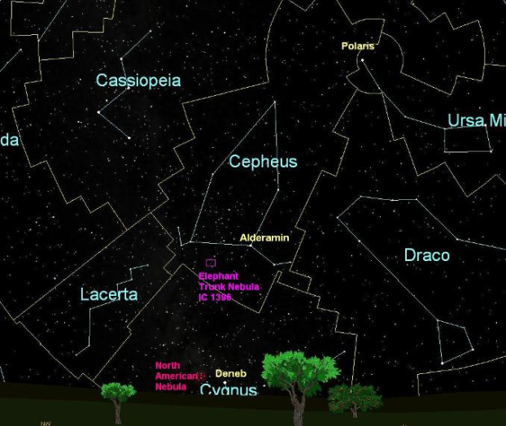
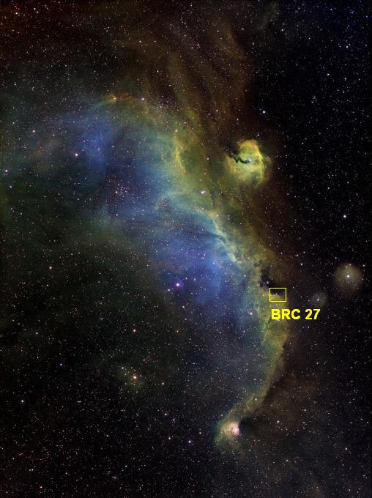
BRC 34 and BRC 38 lie in Cepheus the King, the nearest bright stars are Alderamin and Deneb The image below was created using Starry Night software and Paint.
This is a telescope picture of the Seagull Nebula found at the web page http://www.global-rent-a-scope.com/gras-gallery/nebula-magic/9111699 with the general location for BRC 27 indicated.
(BRC 34)

(BRC 38)

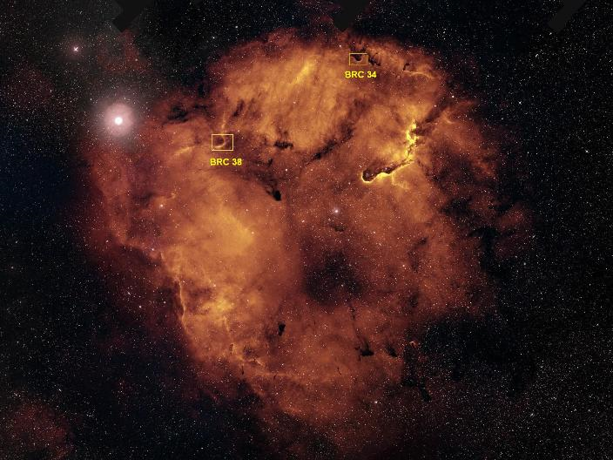

This image shows the locations of BRC 34 & 38 in IC 1396--the Elephant Trunk Nebula.. It is curious to see 38's brighter rim compared to 34's.

Analysis Plan

The main focus of our analysis will be ~10-15 arcminute diameter regions around our three targets (BRC 27, 34, and 38). We will use infrared excesses to look for candidate Young Stellar Objects (YSOs) and to describe the properties of known YSOs in these regions. We will use WISE (Widefield Infrared Survey Explorer) data; the region around BRC 27 is already in the public release, but we will obtain data for all 3 of our regions from the upcoming WISE data release in March 2012. We will use the WISE catalogs and the WISE color selection mechanism from Koenig et al (2011), which is based on the Gutermuth (2008, 2009) Spitzer color selection, to select YSO candidates. These color cuts allow us to remove from consideration objects outside our galaxy such as external galaxies with elevated star forming rates and active galacitic nuclei (AGN), shock emmsion blobs, and resolved structures based on established color restraints. We will then assemble data for our YSO candidates from as many other archival sources as possible, including the literature, investigate the images of each candidate, and perform additional photometry as needed.

Data we already plan to include are from the Two-Micron All-Sky Survey (2MASS), the Midcourse Space Experiment(MSX), AKARI (literally "light" in Japanese, also known as Astro-F). Some Isaac Newton Telescope (INT) Photometric H-Alpha Survey (IPHAS) data for BRC 34 and 38 were reported in Barentsen et al. (2011, MNRAS, 415, 103); if the predicted IPHAS release happens in 2012, we will incorporate IPHAS data for our regions where possible. Additionally, there are ~5 arcminute 4-band Infrared Array Camera (IRAC) pointings in each of these regions obtained with Spitzer. The regions of IRAC 4-band coverage were analyzed for BRC 27 and 34 by a prior NITARP team (Johnson et al., 2012, Rebull et al. in prep; see also Choudhury et al. 2010 for BRC 27) and for BRC 38 by Choudhury et al. (2010) and Chauhan et al. (2009) . For each of these 4-band regions, there are serendipitously obtained "flanking fields" of 2-band coverage with IRAC. We will use these serendipitously obtained data to aid in our assessment of YSO candidates. We will also include any Multiband Imaging Photometer for Spitzer (MIPS) data, as appropriate. The Spitzer data may require us to re-reduce or at least redo the photometry for our targets of interest.

Through Co-I J. D. Armstrong, we will also obtain new ground based optical photometry in the Sloan bands i and r using the 2-m Las Cumbres Observatory Global Telescope (LCOGT) on Haleakala. Ground based data will flush out data set on the shorter wavelength end and help us identify star producing galaxies masquerading as YSOs. These data will need to be reduced and photometry performed on all relevant sources.

If a rereduction of the Spitzer data is needed, we will use MOPEX (Makovoz & Marleau 2005) to construct the mosaics. For both the Spitzer and new optical data, we will obtain photometry using the Aperature Photometry Tool (APT) (Laher et al 2012).

We will collect all the photometry data in Excel spreadsheet form, where we can perform necessary calculations, such as flux density/magnitude conversions, and produce color-color and color-magnitude diagrams as well as spectral energy distributions (SEDs). We will use the shape of the objects in all available images, their colors and locations in color-magnitude and color-color diagrams, their projected location in space, and the shape of their SEDs to assess individual YSO candidates, following the procedure in, e.g., Johnson et al. (2012 -- a 2011 NITARP team), Rebull et al. 2011 -- a 2010 NITARP team), and Guieu et al. (2009, ApJ, 720, 46 -- a 2005-2007 NITARP team)

Education and Outreach

Team C-WAYS is made up of a wide variety of adult and school age learners. Our adult learners include middle school, high school, community college and informal educators. Our school age learners, therefore, will also represent a wide range of ages and abilities. Each sub team of educator and school age learners will spend time immersing themselves in general astronomy concepts and skills necessary to the success of C-WAYS research as appropriate for their age and ability. Some of these concepts and skills are;

- general properties of light and the Electromagnetic Spectrum with special emphasis on infrared
- multiwavelength astronomy with emphasis on wavelengths and image sources that we will utilize; IRAC, MIPS, 2MASS, MSX, AKARI , IPHAS and LCOGT
- life cycle of stars with emphasis on Young Stellar Objects (YSOs)
- infrared excess and its relation to YSOs
- spatial resolution with emphasis on the relative spatial resolutions of WISE vs. Spitzer images
- similarities and differences of WISE and Spitzer missions and why they were designed as they were
- photometry methods and terms, particularly the use of MOPEX and APT
- data manipulation and generation of graphics using EXCEL

With appropriate background schema in place, both adult and school age learners will experience authentic scientific research in a true collegial manner. Based on thorough literature searches, journal articles relevant to our area of study will be read analyzed and discussed. Data acquisition and analysis will take place before, during and after CWAYS’ visit to CalTech in July. Communications between sub teams will take place via regular teleconferences, video conferences, extensive use of the wiki, and email. A Scientific and an Education poster will be created and presented by the CWAYS team at the 2013 AAS based on results obtained through this process.

Participation NITARP will enrich every CWAYS’ learner with the experience of having done authentic research as part of a cross continental team. This experience will not only increase each learner’s knowledge of astronomy and the research process, but will increase their interest and excitement level towards research opportunities. This knowledge, interest and excitement will be payed forward through formal outreach to education and community groups by all learners, as well as informally to adult and school age peers of all those involved.

Team Lincoln Way High School (P. Piper). Teachers and students from several of the districts four schools (including the districts ROTC program) will be involved in this process through the district’s new “distance learning” equipment. Student interest and commitment will be assessed through weekly sessions in which students will learn basic concepts and computer skills. A school page on the wiki will be created and used to share knowledge within this sub group and to reach out to other groups. Outreach will be coordinated with Educational Outreach colleagues at Yerkes Observatory and will include sessions at local, national and international workshops. Past presentations have included local school groups, Yerkes workshops, Illinois Science Teachers Association, and Global Hands on Universe.

Team New Philadelphia High School (D. French). New Philadelphia High School Students will be participating in the NITARP research project as an extra-curricular activity and may apply for the Ohio Flex Credit option. Students will be selected via an application process in March or April 2012. Students will participate in weekly research meetings to discuss background information, journal articles, and to work on data reduction and analysis. They will be responsible for keeping a science notebook for recording notes, comments, and for keeping applicable journal articles. Students will use the NITARP CoolWiki page to obtain additional background information and communicate with other team members. After the January 2012 AAS meeting, they will present their research to the New Philadelphia Board of Education as well as other possible venues and outreach activities.

Team Reedley College (L. Novatne). A small group of college freshman and sophomores will meet weekly. For the first few weeks, the students will be instructed on the basics of star formation and stellar evolution. Once the students understand the basics, they will begin reading the appropriate journals and conduct web research for discussion. Once the data processing instruction has been completed, the students will work together and separately on the data analysis portion of the project. The weekly meetings will introduce the students to; star formation mechanism and stellar life cycle, spectral analysis, black body curves, and photometry. In the fall of 2012, the weekly meetings will be include to the processing of data

These are the references from the 2011 group. We’ll probably use a lot of them, so I’m listing them all and we can add/subtract from the list.
Bibliography
Allen L., et al. 2011, American Astronomical Society, BAAS, 43, 258.15.
Bertoldi F., 1989, ApJ, 346, 735.
Chauhan N, Pandey A.K., Ogura K., Ojha D.K., Bhatt B.C., Ghosh S.K., Rawat
P.S., 2009, MNRAS, 396, 964.
Gregorio-Hetem J., Montmerle T., Rodrigues C. V., Marciotto E., Preibisch T.,
Zinnecker H., 2009, A&A, 2009, 506, 711.
Klein R., Sandford M., Whitaker R., 1980, SSRV, 27, 275.
Makovoz D., Marleau F. R., 2005, PASP, 117, 1113.
Morgan L. K., Urquhart J. S., Thompson M. A., 2009, MNRAS, 400, 1726.
Morgan L. K., Thompson M. A., Urquhart J. S., White G. J., 2008, A&A, 477, 557.
Morgan L. K., Thompson M. A., Urquhart J. S., White G. J., Mio J., 2004, A&A,
426, 535.
Ogura K., Sugitani K., Pickles A., 2002, AJ, 123, 2597.
Sandford M., Whitaker R., Klein R., 1982, ApJ, 260, 183.
Shevchenko V. S., Ezhkova O. V., Ibrahimov M. A., van den Ancker M. E., Tjin A,
Djie H. R. E., 1999, MNRAS, 310, 210.
Soares J.B., Bica E., 2003, A&A, 404, 217.
Soares J.B., Bica E., 2002, A&A, 388, 172.
Sugitani K., Fukui Y., Ogura K., 1991, ApJS, 77, 59.
Sugitani K., Ogura K., 1994, ApJS, 92, 163.
Sugitani K., Tamura M., Ogura K., 1995, ApJ, 455, L39.
Valdettaro R., Migenes V., Trinidad M.A., Brand J., Palla F., 2008, ApJ, 675, 1352.
Valdettaro R., Palla F., Brand J., Cesaroni R., 2005, A&A, 443, 535.
Wiramihardja S.D., Kogure T., Nakano M., Yoshida S., 1986, PASJ, 38, 395.

Rebull, L.M., et al. “New Young Star Candidates in the Taurus-Auriga Region as Selected from the Wide-field Ingrared Survey Explorer.” 2011. ApJ. 196,4.

Maoz, D., Astrophysics in a Nutshell. Princeton University Press. Princeton, NJ. 2007.

Beltrán, et al. “The Stellar Population and Complex Structure of the Bright-Rimmed Cloud, IC 1396N.” 2009. A&A.

Johnson, et al. “Spitzer Selected Young Stellar Objects in Bright Rimmed Clouds.” AAS Poster Presentation. 2012.

