Proposal for CM4Seyferts
A Color-Magnitude Diagram for Active Galactic Nuclei for Type I Seyferts
Educator Team: Nicole Granucci, Oxford High School, Oxford CT
Theresa Paulsen, Mellen High School, Mellen, WI
Thomas Rutherford, Sullivan South High School, Kingsport, TN
Mentor Teacher: John Blackwell, Phillips Exeter Academy, Exeter NH
Science Mentor: Varoujan Gorjian, Spitzer Science Center, Caltech, Pasadena, CA

Abstract
Achieved data from GALEX, NED and SDSS will be used to construct a UV-IR color magnitude diagram for Type I Seyferts are redshifts 0.1 < z < 0.5. This study will continue the research from the previous NITARP groups (2010, 2011) in demonstrating a correlation between the UV luminosity and the IR temperature of the accretion disk in galaxic nucleui (AGN). The previous study in 2010 found a correlation between the Type I quasars at redshifts 0.1< z <0.5, however, the sample size was not sufficient in demonstrating a substantial correlation. More data is needed to complete the plot, therefore data from less luminous objects must be used. In this study, Type I Seyferts of redshift will be used to fill in the lower port of the plot. (2)
Background/Introduction
Active Galatic Nucluei (AGN) are the centers of some of the most violent and active galaxies in the universe. It is speculated that at the center of these active galaxies resides a supermassive blackhole, generally more powerful and massive than a typical blackhole. The supermassive black hole accretes dust and gas from its surrounds, causing the matter to heat up. This causes the matter to emit radiation in the ultraviolet range at very high intensities. The intensities are so bright that when viewing from earth, they look like point sources, or stars. The center of the galaxy (the nucleus) out shines the stars and matter that comprises the galaxy. After a long debate, it was determined that these are galaxies and not stars. The leading evidence to prove that this was a galaxy and not a star is the spectral measurements. Typically, the spectral emission and absorption lines of a galaxies is generally comprised of star like emission lines. This would be appropriate because galaxies are comprised of billions of stars. However, when astronomers looked at the AGN spectral energy distribution, they found non-stellar lines. This signified that the high intensities they are viewing is not from the stars that make up the galaxy, but from a different mechanism. They determined that they are looking at data from the center of the galaxy, not the whole galaxy itself. Therefore, the study of AGN was born.
There are a few types of active galaxies, but in this study, we will focus on two: Seyferts and Quasars. The difference between the two types of active galaxies are their luminosities. Seyfert galaxies have AGN lumonisity comparable to all of the stars in its galaxy, about 10¹⁰ L. Quasars have a AGN that are about 100 more luminosous than the stars in its galaxy, therefore they are typical much brighter. Among these tpyes, there are subtypes of galaxies, Type I and Type II. Galaxies can be view at difference angles from Earth. Type I galaxies are described as face-on galaxies. This angle gives a direct view of the center of the galaxy, much like looking down from above. There is no obstrustrion from the gas and dust from the galaxies itself, therefore it gives a clear view of the nucleus. Type II galaxy is viewed through the gas and dust of the galaxies. The galaxy is obstructed by the gas and dust of the stars, therefore the view of the center of the galaxy is not clear. These typically are fainter because of this and therefore are more difficult to locate.
In this research project, the goal is to create a color-magnitude diagram for AGNs. The magnitude of these AGNs will be measured using the luminosity of the disk accretion process. As stated above, the surrounding dust and gas is being drawn into the supermassive blackhole at the center of the galaxy. The process is beginning conducted at such a fast pace, that the matter emits radiation in the UV range. Data taken from the UV range will give use the magnitude of the AGN. To find the color of the AGN and therefore, the temperature, we will be using data from a related process. As the accreted material is giving off radiation in the UV, that radiation is also be absorbed by the surrounding dust, which excites (heats) the dust and remits it in the infrared spectrum. Using IR data, we can find the temperature of the AGN. As one might expect, the more luminosous the source, the more its going to heat up (the dust). We should see a linear relationship when plotting the Magntiude vs. Temperature. If we can generate a plot of the color and magnitude of the AGN, then we can use it as a standard way to measure the actual distances of these AGNs, which currently is unknown.

Scientific Goals
In this research project, the goal is to add fainter galaxies to the current color-magnitude diagram as done previously by the NITARP 2011 group. The plot was generated with Type I Quasars, but found that it needed more data to generate a more sound correlation (see Figure 1).
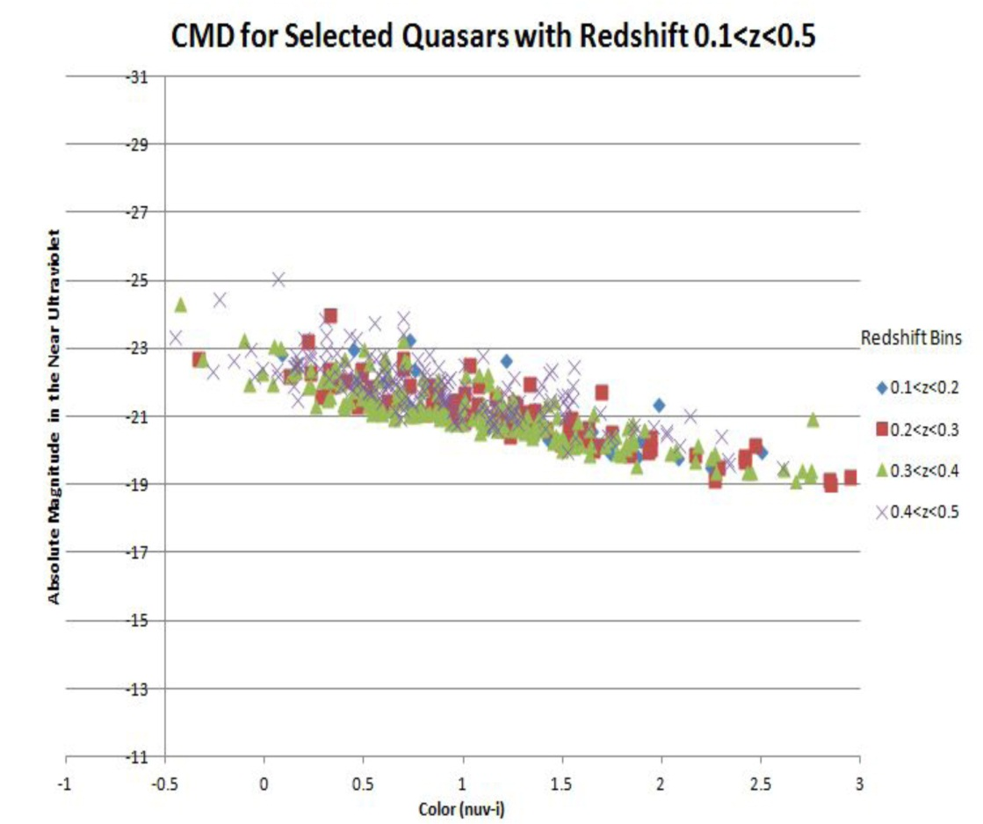
Figure 1. Color-magnitude diagram from Gorjian et al (2011) using GALEX filters in the NUV and SDSS data. A correlations can be observed between the magnitude and the color, however, the sample size is small, preventing statistically significant results to be gained.
We intend to:
- Focus on Type I Seyferts. Although this has been done previously as in NITARP 2010 group, the available data has increased significantly from 2010, allowing more data to be collect and hence a better data set.
- Sources will be selected with a similar redshift values of 0.1 < z < 0.5 to be consistent with the previous work and to eliminate the need for addition redshift correction.
- Use data obtained at a similar time span (appromixately 5 years) for the different wavelengths. This will minimize variability effect from the two events (emission in the UV and reemission in the IR).
- Use data from GALEX and SDSS, allowing for an increased number of sources at the desired wavelengths. Due to redshifts which cannot be avoided, GALEX must be cross referenced with SDSS. SDSS has a much more sensitive at finding fainter magnitudes, therefore it will be used to find Seyferts.

Achieved Data

Public Outreach
- Present at the NSTA
Nicole intends on submitting a proposal to present/chair a workshop at the NSTA Conference in Boston 2014. She will present her work completed during the NITARP experience, How it can be used to promote research in the classroom and how to participate in the NITARP program.
- Present at Oxford’s Annual Science Symposium
Nicole will have her students present at Oxford’s Annual Science Symposium in conjunction with the applied research students. The science symposium is open to the Oxford community, parents, teachers and students. It is a night where students can present their research projects with the community. In addition, Nicole will briefly present about the experience to the Oxford Community.
- Offer Research Opportunities for future Applied Research Students
Nicole will use the experience and research that was conducted during the NITARP experience and show students how to conduct their own astronomy research using the available databases.
- Start a Local Astronomy Club for students and community members
Students involved with NITARP will represent a new astronomy club for the Oxford Community. She will have the students generate astronomy sessions once a month to promote astronomy education.
- Offer Teacher Workshop: Applied Research Programs/Astronomy
Nicole plans on offering a workshop on how to promote research for students in addition to sharing the research experience through NITARP. The workshop will consist of describing the needs for research, how to drive students to conduct authentic research projects and to demonstrate the accessibility of astronomy data for research.
- Give talks at local museum: Peabody Museum

