Using Archival Data to Create a Color-Magnitude Diagram for Type I Seyferts
Educator Team: Nicole Granucci, Theresa Paulsen, Thomas Rutherford
Mentor Teacher: John Blackwell
Science Mentor: Varoujan Gorjian

Abstract

Data from the Sloan Digital Sky Survey (SDSS) and the Galaxy Evolution Explorer (GALEX) satellite will be used to extend the work of the 2010 and 2012 NITARP teams in demonstrating a hypothesized correlation between the luminosity and color (temperature) of the accretion disk within Type I Active Galactic Nuclei (AGN). The 2012 NITARP team was successful in finding a trend in the UV luminosity and color of the AGN in Type I quasars, however the sample size was not sufficient in demonstrating a substantial correlation. More data are needed to see if a more substantial correlation exists; therefore, data from less luminous AGN must be used. Our project will attempt to investigate whether a more significant trend is revealed when Type I Seyfert galaxies with redshifts 0.1 < z < 0.5 are added to the 2012 team's quasar sample.

Background

Active Galactic Nuclei (AGN) are the centers of some of the most violent galaxies in the universe. Their intensity is so bright that when viewing from earth, the galaxies can look like point sources, or stars. Spectral emission lines provide evidence that these objects are not stellar. As matter falls in under the gravitational force of the supermassive black hole located in the center, thermal processes in the accretion disk cause the disk to radiate light across the entire electromagnetic spectrum, peaking in the ultraviolet. (Shu 1982).

The two largest subcategories of AGN are quasars and Seyfert galaxies. The primary difference between them is in the amount of radiation produced in their cores. Quasars are most luminous, having core luminosities that exceed all of the stars in the host galaxies by about 100 times (10¹³ L⊙). Seyfert galaxies are less luminous than quasars. The core luminosities of these galaxies are approximately equal to that of all the stars in the host galaxy (10¹¹L⊙) (Shu 1982).

AGNs contain a concentration of dust in a ring around the accretion disk called a torus (Figure 1). According to the Unified Model of AGN, when a galaxy is tilted toward earth such that we can see into the center of the ring, the light from the accretion disk is nearly unobscured and velocity broadened hydrogen emission lines can be seen in the spectra due to the intense speed of gas clouds encircling the black hole. AGN in this orientation are classified as Type I galaxies. Type II galaxies are oriented in such a way that we cannot see into the ring and therefore the light from the accretion disk is obscured and only narrow emission lines from the outer gasses are visible. For this reason, only Type I AGN will be targets of this investigation.

Figure 1: A Model of a Type II Active Galactic Nucleus. Source: Urry and Padovani (1995)
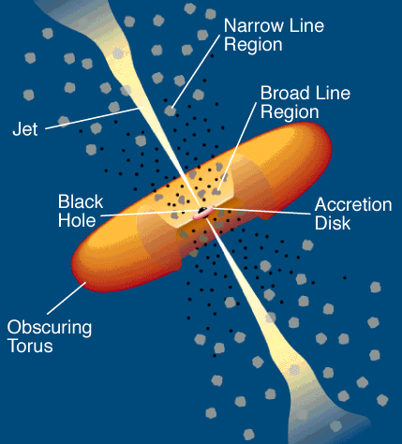

Two previous NITARP studies worked to find a correlation between Type-I AGN absolute magnitudes and their colors (and thus temperatures). The expected source of this correlation comes from the blackbody radiation generated in the hot gas disk that is accreting onto the central black hole. Much like the hot, blackbody emitting photospheres of stars produce a strong correlation between their color and absolute magnitudes in the Hertzsprung-Russell diagram, the expectation is that a similar correlation between color and absolute magnitude should exist for the hot, blackbody emitting accretion disks of AGN. Currently a color-magnitude diagram for AGNs has not been established. The benefit of using this data is to give a method to determine more precise galactic distances, used for understanding galaxy and universe evolution.

The first study by the 2010 NITARP team (Gorjian, et al 2011) did not have enough data to discern any correlation with the 30 data points. The 2012 NITARP study (Curtis, et al 2013) had over 470 data points with newly released data from SDSS and GALEX. A relationship was found (Figure 2) but not one which would allow predictability of AGN absolute magnitudes given their color. This study will focus its attention on the inherently less luminous Seyfert AGN to discern any correlations between their absolute magnitudes and colors using similar data sets.

Scientific Goals

Type I Seyfert galaxies will be examined using data provided by the NASA Extragalactic Database (NED). Specifically, AGN that were imaged by both SDSS and the Galaxy Evolution Explorer (GALEX) will be studied. The goal is to continue the work of the 2010 NITARP team (Gorjian et al 2011) and 2012 NITARP team (Curtis et al 2013) team to produce a color magnitude diagram (CMD) showing the hypothesized correlation between UV luminosity and color of Type I AGN. This project will extend the earlier quasar based results (Figure 2) to include less luminous AGN.
Figure 2: 2012 Team Results. A CM Diagram which shows the correlation found between absolute magnitude of the Type I AGN studied and their nuv-i color. Different symbols correspond to different bins of redshift, z.

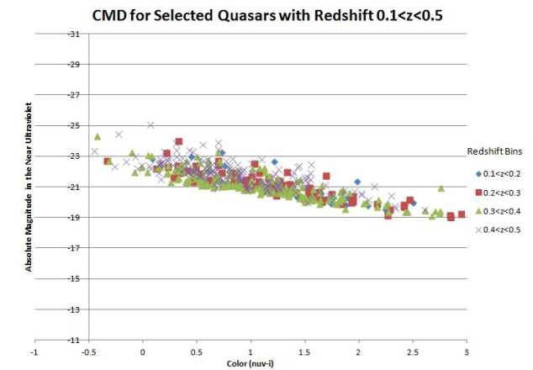

As in the case of the 2012 NITARP team, color will be determined as the difference between the magnitudes in the near ultraviolet (GALEX) to the i-band (SDSS).

We intend to:
- Focus on nearby Type I Seyfert AGN to avoid obscuration of the accretion disk. Sources will be selected at similar redshift values (0.1< z <0.5) to be consistent with the 2012-team data and to avoid the need to correct for redshift variation by probing a relatively narrow redshift range.
- Use photometry data obtained within approximately a 5-year period to minimize error due to variability.
- Use data from GALEX and SDSS to increase the wavelength range for the color. Due to the redshift of these sources, GALEX data alone cannot be used since redshifted Ly-α lines are a strong contaminant at the wavelength measured by the far UV GALEX filter. Only the GALEX near UV filter can be used.

Expected Outcomes

We hope to extend the correlation that was found between the UV-i band color and the UV luminosity of quasars by the 2012 team (Curtis et al 2013) down to the less luminous Type I Seyfert AGN, which hopefully will be a steeper and hence more predictive correlation.

Choosing to pursue less luminous AGN, like Seyferts, does create a situation where the AGN light may be diluted by the host galaxy starlight. This effect will not be the same as the AGN correlation and should introduce a scatter superimposed on top of any AGN correlation as a host galaxy's starlight contribution is unrelated to the AGN luminosity.

If a more robust correlation for color and magnitude can be shown, then such a diagram will allow the distances to other AGNs to be determined simply by looking at their colors. This, along with their redshifts, will allow greater confidence in determining their distances from Earth.

Archived Data

Source selection to accomplish the above was done using the NASA/Extragalactic Database (NED) which yielded over 10,000 sources which were identified as Seyfert galaxies by the SDSS. Those sources were then fed into the GALEX archive which identified 2000 of the SDSS sources which also had GALEX data.

Both archives provide photometry in the AB magnitude system and the redshifts of the sources will be used to determine their distances and hence their absolute magnitudes.

Instruments

The Galaxy Evolution Explorer (GALEX) instrument is an orbiting space telescope with a large field of view imaging at two UV wavelengths:
151.6 and 226.7 nanometers. GALEX’s recent data release has increased the number of target sources for our research. Further, the data from GALEX focuses on faint objects which provide a larger sample of low luminosity AGNs.

The Sloan Digital Sky Survey uses a ground-based 2.5m wide-angle optical telescope that images using a photometric system including UV, green, red, infrared (806 nm), and i-band filters (763.0 nm). Only the i-band filter data will be used from the SDSS since this yielded the tightest correlation in the NITARP 2012 study.

Education Goals

Nicole Granuucci intends to:
- Present at the NSTA
Nicole intends on submitting a proposal to present/chair a workshop at the NSTA Conference in Boston 2014. She will present her work completed during the NITARP experience, how it can be used to promote research in the classroom and how to participate in the NITARP program.
- Present at Oxford’s Annual Science Symposium
Nicole will have her students present at Oxford High School’s Annual Science Symposium in conjunction with the applied research students. The science symposium is open to the Oxford community, parents, teachers and students. It is a night where students can present their research projects with the community. In addition, Nicole will briefly present about the experience to the Oxford Community.
- Revise Applied Research Curriculum to reflect NITARP experiences
Nicole will revise the curriculum for the Applied Research Course to reflect on the NITARP experience of conducting research. Nicole will include how to write a proposal, collaboration, discuss data analysis techniques and uses of available data.
- Start a Local Astronomy Club for students and community members.
Students involved with NITARP will represent a new astronomy club for the Oxford Community. She will have the students generate astronomy sessions once a month to promote astronomy education.
- Offer Teacher Workshop: Applied Research Programs/Astronomy
Nicole plans on offering a workshop on how to promote research for students in addition to sharing the research experience through NITARP. The workshop will consist of describing the needs for research, how to drive students to conduct authentic research projects and to demonstrate the accessibility of astronomy data for research.
- Give talks at local museum: Peabody Museum

Theresa Paulsen intends to:
- Work with her students to share their NITARP experience with the entire student body, staff, and community in Mellen. They will be able to reach people throughout the community through their elementary science shows and family science night.
- Lead workshops for educators at the regional and state level including a regional teacher in-service and the annual convention for the Wisconsin Society of Science Teachers (WSST).
- Prepare an article with her team of students about the experience for the local newspapers, the school web page, and the WSST newsletter.
- Keep a blog of the experience on her “NASA Adventures” page of her classroom website: www.digginscience.weebly.com
- Prepare a podcast about the experience for her classroom YouTube channel: http://www.youtube.com/user/DigginScience98
- Present to general audiences at a local restaurant that hosts a monthly science café where science professionals frequently discuss their research with the public.
- Curriculum will be developed for further investigations using archived data in science classes such as Physics, Chemistry, Physical Science, and Astronomy.

Thomas Rutherford intends to disseminate the procedures and results of this project to the community in several ways:
- Outreach to the public will be achieved by giving several talks over the course of the project and after. The main public venue will be presentations in front of local astronomy clubs, such as the Bays Mountain Astronomy Club at Bays Mountain Park and Planetarium and the Bristol Astronomy Club at King College.
- Education programs will be given in the form of teacher workshops to other teachers in the district as well as to teachers in other surrounding districts. Also, a couple of talks will be given at two local universities (East Tennessee State University and the University of Tennessee) to their education majors as well as a Physics Dept. seminar.
- Tom will propose giving a presentation about the NITARP program and student research projects at the 2014 Regional NSTA Convention in Richmond, Virginia.
- Students will present the results of this research project to the local school board and will publish the results in a suitable venue—in Tennessee, the Journal of the Tennessee Junior Academy of Sciences is a possible choice—Tom’s current research students publish their papers there.
John Blackwell intends to use this project in several ways to educate the public, students, and other teachers:
- Public outreach will be achieved by lectures at the McAuliffe-Shepherd Discovery Center, Concord, NH. The Discovery Center is a combined museum/planetarium/education center for both teachers and students to learn more about space, space flight, astronomy and astrophysics. They host lecture programs (Super-Stellar Fridays) to the public and professional development programs for teachers. John has spoken at this venue regularly for over ten years with groups ranging in size from 50 to over 100 and at age levels from kindergartners to adult. John is planning to do both talks and professional development workshops for teachers within this year.
- Teacher workshops: John is planning the next Phillips Exeter Academy Astronomy Education Conference for June of 2013. Attending this conference will be 14 high school astronomy teachers. Among the many topics covered in this week-long conference will be this NITARP project and the use of publically available data sets which can be used in the classroom for science education.
- The Local Astronomy Clubs: The New Hampshire Astronomical Society (NHAS) and the Academy’s student-run astronomy club both have opportunities for speakers to present interesting research and opportunities for others. This NITARP project would be presented to the 200+ members of the NHAS and the 60+ students in the astronomy club.
- Classroom activity: John will use this project in his Advanced Astronomy and Observational Methods in Astronomy courses allowing the students to get the feel of astronomical research using modern data-mining techniques. An outcome of this activity will be lesson plans, videos and assessment material aimed at advanced high school and introductory college level astronomy students. Currently over 150 students enroll in astronomy courses throughout the year.

References

Curtis, Wendy; Gorjian, V.; Thompson, P.; Doyle, T.; Blackwell, J.; Llamas, J.; Mauduit, J.; Chanda, R.; Glidden, A.; Gruen, A. E.; Laurence, C.; McGeeney, M.; Majercik, Z.; Mikel, T.; Mohamud, A.; Neilson, A.; Payamps, A.; Robles, R.; Uribe, G. 2013, American Astronomical Society, AAS Meeting #221, #339.39; "Color Magnitude Diagrams for Quasars Using SDSS, GALEX, and WISE Data"

Gorjian, Varoujan; Meredith, K.; Petach, H.; Ramseyer, E.; Spuck, T.; Abajian, M.; NITARP Luminous Data Miners Team 2011, #142.43; Bulletin of the American Astronomical Society, Vol. 43, " Determination of the Infrared Luminosity of Active Galactic Nuclei (AGN)"

Peterson, B. M. An introduction to active galactic nuclei, Publisher: Cambridge, New York Cambridge University Press, 1997

Urry, C. M. and Padovani, P. 1995, PASP, 107, 803

Shu, Frank. The physical universe: an introduction to astronomy, University of Science Books, Mill Valley, CA, 1982 pg 306-320

