Our study will focus on triggered star formation and attempt to determine the types of star formation that are occurring a small region of the sky. Most star formation begins due to spontaneous processes on a galactic scale, but triggered star formation takes over and extends the star formation process according to Elmegreen 1998. The presence of dense or compressed gasses is necessary for all star formation. If there is enough mass/density, gravity alone will produce a star. Triggered star formation occurs when an outside source of energy triggers the formation of a star before conditions become sufficient for free fall.

Observations of types of triggering are organized into three categories;
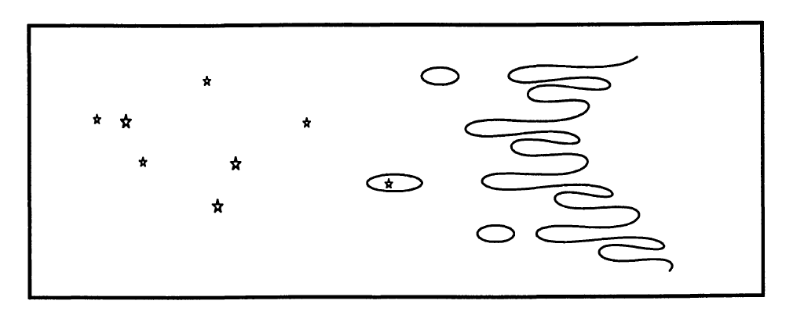
- small scale triggering which consists squeezing areas of density from all sides
- intermediate scale triggering which consists of pressure from one direction that moves through an existing area of density creating a wave front of increased density that produces stars, sequentially younger stars are produced as the front moves further from the pressure source
- large scale triggering which consists of an expanding H II region around a massive star colliding with surrounding gasses producing a ring or shell of density and star formation
Figure ? Schematic from Elmegreen (1998) showing clumps being squeezed to produce protostars

Elmegreen (2008) describes three morphologies produced during the process of pressure induced triggering.
- Individual high pressure clumps or protostars
- A high pressure clump or protostar with a cometary or elephant trunk tail trailing away from the pressure source.
- Bright rims of increased density and star formation along the pressure front

The physical and sequential distribution of protostars within various structures is dependent on the type of triggering mechanism along with factors such as chemical makeup, internal motion, turbulence, magnetic waves, fragmentations, heating and cooling ionization. Magnetic fields in particular may affect the morphology in a star forming region by producing filaments of density. Stars produced in filaments, regardless of the process, will be segregated geographically.

One way of eliminating some of the many variables affecting distribution of protostars is to focus on a small region of star formation. Small regions in close proximity formed under very similar if not identical circumstances hold constant many of the possible variables in an almost “controlled environment”. The processes by which protostars were created in these regions can then be considered where the physical and/or age distribution vary and multiple processes identified if they exist.

Evans et al. 2009 chose to study star formation in five nearby molecular clouds based on their similarities in their study “from molecular cores to planet forming disks” (abbreviated c2d) using primarily Spitzer data. The slope of SEDs, bolometric temperature, and color-color diagrams were used to determine class. Criteria for this study only allowed for protostars that were detected in all Spitzer IRAC bands (3.6 – 8.0 micron) and Spitzer MIPS 20 micron and showing an infrared excess resulting in young stars through Class II and the beginning stages of Class III as infrared excess diminishes in Class III. This method also misses the youngest stars that are deeply embedded, with the majority of their emissions coming from their dense cloud at much longer wavelengths. In our proposed study, Herschel data will see the dust of the youngest stars clearly at longer wavelengths allowing us to better identify Class 0 and Class I stars.
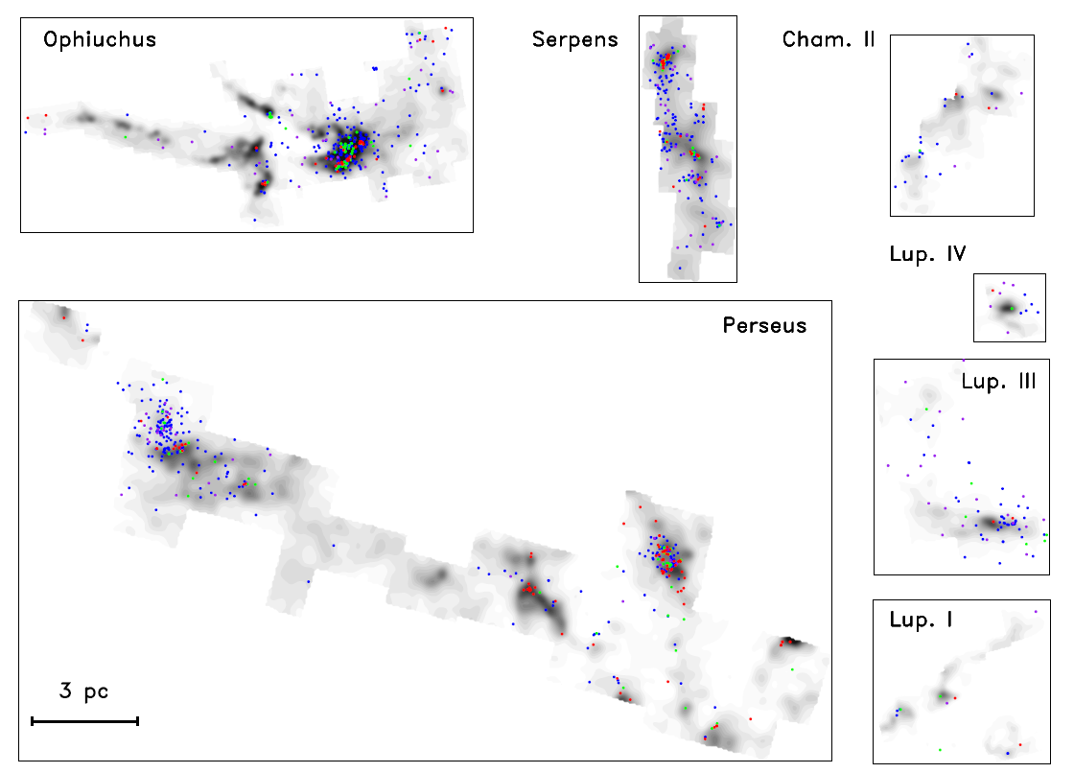
Star Formation Rate (SFR), a measure of mass per unit time, was then used in the c2d study along with class determination to calculate an estimation of how much time stars spent in each of these classes. Further calculations of Star Formation Efficiencies (SFE), a ratio of the mass of the protostars to the total mass of the cloud, and star depletion time (tdep) were also made. Associations between classes and physical distribution within the clouds showed the youngest objects to be in the densest clusters in areas of high extinction with older stars having dispersed over time as seen in figure ??. were also considered. We will use these same or similar methods in our proposed study on a region that has even tighter “controlled environment” allowing us to compare SFR, SFE, tdep, physical and age distribution of different clumps within the same star forming region but with the advantage of being able to “see” the youngest protostrars using Herschel.
Figure ? Location of youngest to oldest protostars (red, green, blue, violet in terms of increasing age) on an extinction map of clouds studied by Evans et al (2009)

I

